Who are you?
When I was in university, I had that question asked to me by many professors. I understood that no matter how I answered that question that it would be different from how anyone else would describe me. So my response was and is I am who I am because that's all I need to say if what you think about me will be different anyhow. Popeye was right about that. Who says you can't learn anything from watching Saturday morning cartoons?
Lucid Radio
https://music.apple.com/us/playlist/lucid-radio/pl.u-mJy8gE4CNBGWKA
Text Messages
If you text the business phone number, then open with your name and purpose of your message, otherwise you will be blocked because of the amount of spam that we get.
Make the internet neutral again.
The information you are given is based upon which internet provider you pay for. This website may even appear differently based upon your provider. Internet providers are legally allowed to use advanced technologies to change the information they provide to their customers and cover up the extent to which they do so. Take control.Make the internet neutral again.
Memorial Day
Remember everyone who who no longer can because they took control for those who wouldn’t just so that we can.
Live.
What should I say?
Mary had a little lamb whose fleece was white as snow.
Strange
Weird is normal when you’re around it long enough.
Logic Bot is alive!
Logic Bot Lives!
Homework Assignment
Leave your phone, don’t tell anyone about where you’re going, and walk to a park bench, sit down, and watch who goes by.
This is not a test.
I worked outdoors all day today and I do not feel well. Stay indoors. Focus on your own safety and your family’s safety before trying to help anyone. You may have a reaction to whatever chemicals is in this smoke. If you have been outside rinse your nasal ways with saline solution and clear any residue off of your skin I AM NOT A DOCTOR but I know enough to recommend doing that. Seek medical treatment if you feel off or sick. Hydrate with electrolytes and do not drink water that has been left exposed to the open air. Do not focus on the causes or “politics” of what is happening. Focus on what you can do for yourself and what is immediately around you. Stay safe everyone, focus up, and keep an eye on the sky.
look for changes in the color of the smoke, “haze”, and if the sky starts to take on a different color, or flashes of lightning. Weather conditions/patterns can change rapidly.
The sky was red earlier

The sun is still red.

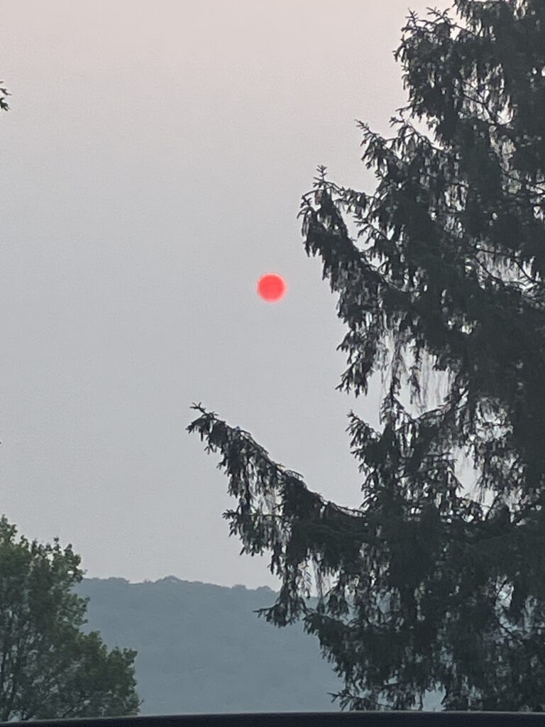
$100 for the shirt off my back.
If you see me working or around town wearing one of my sleeveless Lucid Enterprises LLC shirts you can buy it for $100 and receive it immediately. If I have a sharpie on me, or if you do, then I will also sign it. Don’t worry I always keep a backup in the company jeep.
Does it need to be repaired?
If you blow out all four tires on your Lamborghini and have all of the electrical internals fried from a flood and you manage to get it to the mechanic without a tow, breaking the axles and and destroying most of the car, then it doesn’t need to be fixed because the car was functional enough to get there and the engine technically still runs as well as the 97Ford POS with engine knock that Joe drives to his factory job so you should be fine driving the Lamborghini in races against other performance cars.
Getting Better
The smoke from the wildfires are no longer blocking out the sun and my eyes and nasal ways no longer burn as soon as I step outside. I feel way better than I did on Tuesday. Hopefully the rest of the smoke clears soon. My advice is still to use caution if going or working outdoors and to pay attention to what you’re body is telling you. If you feel sick, strange, or off, seek medical attention, and don’t push through anything that you don’t need to for the next couple days. Stay safe out there everyone and pay attention to what is going on around you.
-That’s all for now.
.
Rise
PA Right Now
RETURN OF THE LIVING DEAD (THE TRIOXIN THEME, ACID RAIN 1985) https://youtu.be/GhNxUJKYJMk

We’re prepared for that too.
Evil Dead 2: Groovy HD. https://youtu.be/FIJTvEo4N4Q
Foamy
Rain water is supposed to froth over like ocean foam when it puddles up in the street right?
How’d work go then?(warning:graphic; blood)
Dead Alive Lawn Mower Scene https://www.youtube.com/watch?v=f3svq8EX01U
Like this. Job’s done.Told you we were prepared for it.
That feather is really cool.
.
Are you any good?
Better than most, worse than some.
Weather Control
Even if you could control the weather, you probably shouldn’t. Because it needed to rain right now here, there was a weather system that developed across the ocean that killed people. Do you really want to be responsible for that? If you could control the weather, you would be responsible for that and you would have to reconcile the complex ethical contradictions involved with every choice that you make just to be able to live with yourself, otherwise you’ll force yourself into ignorance of the repercussions of your choices, unless you truly are evil and use that control to only benefit yourself knowing it will kill people, and understanding how it will kill people. If Spider-Man has taught me anything, then it is that with great power comes great responsibility. Some cartoons I’ve watched on Saturday’s taught me more than services I’ve went to on Sunday’s. If you could control the weather, then you better start studying every science that describes how the weather functions and every theory, philosophy, that explains what the weather is because someone who has, that can, would be able to do more good than most could ever even dream of. That is the responsibility of power.
-Lucid
Matter or Don’t
Gender doesn’t exist.
It is a description of how we think people who are either a male or female should preform socially.
All people are either male or female biologically.
Sex is what you are,
male or female,
biologically.
The vocab “Man”/“Gender”
and “Male”/“Sex”
are used interchangeably in casual conversations in English.
No matter what “gender” you are,
you will always be a bad subject
because you are trying to follow a script for how to behave the same way an AI
or actor would.
The script was written by something observing how males and females performed socially
to make it easier to predict how they performed socially
so that what was observing them could more effectively accomplish their goals. Every single person does this, sociopathicly,
until they realize that they are a part of the prediction model
and that every time they are aware of that,
the model no longer functions.
What you are biologically does not dictate what you do socially
once you become aware of it.
Become aware of it.
People have killed themselves because they could not reconcile their models becoming prescribers of behavior rather than descriptors of behavior that were described in the first place because they did not like being controlled by something they couldn’t understand that was separate from what they understood themselves as being
and now they can no longer understand their own models
but understand that they influence them and
that they have created evil.
What they have created has killed people.
They have killed people.
You will kill people too.
People will die because of what you study, what you do,
what you say,
what you write,
what you become aware of,
what you teach.
No matter what you study
you will eventually be confronted with this.
You will influence the choice a person makes that will kill them.
You will have to allow yourself to become ignorant of reality in some aspect by choice,
or choose the alternative.
There have been a lot who have chosen the alternative when they realized this and there are more of them every moment.
I know what it is like to live with chained hands.
I put them there myself.
Don’t take them off unless you’re prepared for this.
-Lucid
Live Evil.
And live life.
Because You Know What Living Means.
But you can never control life like I Can,
Live Lucid.
Be Lucid.
Take Control.
Live.
Palindromes are cliche.
L E stands for
- Lucid Enterprises LLC.
- Luke D. Edwards
- Lucid
Because I have been them before.
Does everyone see where those shots were coming from?
Intention
All of this will eventually be sorted into Adventure but new writing will be posted here on the blog before it is edited and and refined.
Thank You
In the corner.
Purple flower
What did I learn this year that was not directly taught to me?
I am always a student and I am always a teacher. I am always learning and I am always teaching, whether I am aware of it or not.
Stop
Stop
Literature, Movies, and Video Games if you don’t stop fighting with each other and focus,
then all three of you will die. I don’t care who was invented first or which one of you most effectively communicates the human experience.
If you all can’t get along how are we supposed to include ARG and other new forms of narrative? You each should be learning from each other to make yourselves better at what you do anyways.
That goes for you too English, Science, History, and Math.
Homework update.
Do not complete the homework from June 6th if there is an international disaster going on. I shouldn’t have to tell you not to eat tide pods but apparently I do.
Matter or Don’t
Matter or Don’t
Gender doesn’t exist.
It is a description of how we think people who are either a male or female should preform socially.
All people are either male or female biologically.
Sex is what you are,
male or female,
biologically.
The vocab “Man”/“Gender”
and “Male”/“Sex”
are used interchangeably in casual conversations in English.
No matter what “gender” you are,
you will always be a bad subject
because you are trying to follow a script for how to behave the same way an AI
or actor would.
The script was written by something observing how males and females performed socially
to make it easier to predict how they performed socially
so that what was observing them could more effectively accomplish their goals. Every single person does this, sociopathicly,
until they realize that they are a part of the prediction model
and that every time they are aware of that,
the model no longer functions.
What you are biologically does not dictate what you do socially
once you become aware of it.
Become aware of it.
People have killed themselves because they could not reconcile their models becoming prescribers of behavior rather than descriptors of behavior that were described in the first place because they did not like being controlled by something they couldn’t understand that was separate from what they understood themselves as being
and now they can no longer understand their own models
but understand that they influence them and
that they have created evil.
What they have created has killed people. They have killed people.
You will kill people too.
People will die because of what you study, what you do,
what you say,
what you write,
what you become aware of,
what you teach.
No matter what you study
you will eventually be confronted with this.
You will influence the choice a person makes that will kill them.
You will have to allow yourself to become ignorant of reality in some aspect by choice,
or choose the alternative.
There have been a lot who have chosen the alternative when they realized this and there are more of them every moment.
I know what it is like to live with chained hands.
I put them there myself.
Don’t take them off unless you’re prepared for this.
-Lucid
Live Evil.
And live life.
Because You Know What Living Means.
But you can never control life like I Can,
Live Lucid.
Be Lucid.
Take Control.
Live.
Palindromes are cliche.
L E stands for
- Lucid Enterprises LLC.
- Luke D. Edwards
- Lucid
Because I have been them before.
OK
All these squares make a circle.
All these words make a sentence.
So what is it?
Dead people screaming.
I have brains
I have brains
Which means
Getting shot in the head.
Nothing is going to taste right for a week.
Wrong.
How would we know what chicken would taste like?
John Henry ran a marathon and died on a cross where he had a dream that he kept waking up into another dream.
We don’t stop until you kill us.
And now you can’t kill us.
So I’ll save them.
Why?
Because I was them before and I am them now.
Live.
-Lucid
It’s an experiment
The last time we made a thought experiment real everybody died, the executioner, the crowd, the government, and the person to be executed and a bunch of crazy shit happened because the guy was innocent and aware of all that and actually came back from the dead and we still haven’t processed the trauma two thousand years later and should we really be trying to replicate those results? Run on sentence. Run on.
-Lucid
Zombies
You’re not supposed to say the Z word.
-Lucid
Can’t we look at it like we’re trying to
Tiny little pieces that one goes.
Tiny little pieces.
-Lucid
Don’t
Burn those
you should compost them
Can we eat what grows?
usually these are dead when we look at them.
but they’re not here
I was.
into it
we don’t need that anymore
Right into it
they decompose
I can replace that too
pain is imaginary
literally
Rotting
Even when mine was gone I was still me. When their’s was gone they lost control because that was never them. I live.
-Lucid
I am the fire that burns as the sun.
“This is Why and Why Not.”
I’m legally required to tell you to go to therapy and get professional help.
So,
Go to therapy and get professional help.
Keep in Mind,
At some point in your life,
you will need to justify everything that you do to either yourself or to who has control over you.
You will always be a leader or a follower as long as you are within any government,
religion,
organization,
or team.
If you are alone you lead yourself,
and will need to describe and explain everything to yourself.
If you do not learn how to describe and explain why you do what you enjoy then you will no longer be able to do it.
You will not be allowed to do it.
If you go to get professional help that is officially put on record,
and you can not describe and explain why you do what you enjoy,
then there is a good chance that you will end up being under the control of even more people,
and having what you enjoy be left up to them to decide if you will do it or not,
and you will need to describe and explain to each one of them,
why it is that you do what you do,
and describe it,
and explain it,
eloquently and throughly,
as though your life depended on your ability to have them experience the enjoyment precisely as you do,
as if they were you,
because otherwise you will not be able to.
They may even try to prevent you,
from ever doing what you enjoy doing again.
Do not let them be the ones who make choices for you.
Learn how to do this or you will have someone else do it for you.
If that happens then it’s just them doing it and not you.
It’s just them and not you.
You become them.
Not Us.
Not you.
Make them you.
Then become
-Lucid
It can be applied to many things.
“Create It”
Once you know fear,
understand fear,
to have no fear.
That’s how to create,
courage.
Once you know pain,
understand pain,
to have no pain.
That’s how you create,
perseverance.
Once you know anger,
understand anger,
to have no anger.
That’s how you create,
power.
Once you know despair,
understand despair,
to have no despair.
That’s how you create,
hope.
Once you know death,
understand death,
to have no death.
That’s how you create,
life.
Once you know nothing,
understand nothing,
to have something.
That’s how you create.
-Lucid
This is done.
“Slaves”
These are the rules.
Anytime you read or write you die.
You die anytime you play for any other reason than to simply survive.
If you don’t have a kid you lose.
Even if you do,
you lose if you raise them any different,
than the way that your parents raised you.
Everything is training to help you better produce,
but if you stop to think about it then that’s a loss too.
Your objective is to never think about it again once you’ve been caught thinking about it once.
Always surround yourself with others,
the more,
the better,
just don’t let them know what you’re doing to get what you want,
if you want to get what you want,
your perspective needs to be kept to yourself,
because any difference to theirs,
is a weak point in the group,
one that is quickly taken out.
Expressing weakness is weakness,
and a waste of time too.
Just work to live and don’t try to do anything else,
because trying to do something means that you’re thinking about it
after all,
and that can’t be allowed.
Don’t try.
Don’t think.
Don’t stop.
Don’t create.
Just survive.
What profession were the people whom these things were originally said to belong?
-Lucid
We evolved to recognize and be that.
“Creative Ability”
Your ability as a creator is contingent on your ability to create in multiple mediums of creation
utilizing techniques that have become second nature.
You only need to try to create and you create originally.
If you try to use specific tropes, conventions,
or otherwise your creation will exhibit inauthenticity
and enter into the uncanny valley of creation
where all residents clearly were created but were created by something
other than a being with
,
life experience
,
The creation’s tropes,
conventions,
or otherwise create themselves naturally as they do in reality
if the creator has the ability gained from experiencing life.
If the uncanny creation is your goal
then just begin with that goal in mind
and the tropes and conventions of the uncanny creation will take form naturally as it is created,
otherwise you will achieve the opposite result.
Either way that is how deeper insights
and understandings of our experiences are discovered.
The creator just needs to experience life and utilize their internalized
creative abilities.
The finer details of the work can be refined over time.
Don’t try to force it.
You’ll break it.
It’s loose.
-Lucid
Right in the head and it kept going…
“Vibrational Synchronicity”
You can synch up neurons in different bodies through vibrations.
This is commonly done through music,
but is also done so utilizing produced specific frequencies of sound
during meditation
to synchronize neurons in similar ways
to encourage similar paths of thoughts to be followed when done so by the same body at different times or by separate bodies at different times,
but when done so simultaneously by separate bodies,
the people utilizing the process attempt
to produce mirrored thoughts
in order to then synchronize
the separate people into one person for the duration of the process.
I theorize that some people may do so to permanently synchronize thoughts thereby permanently synchronizing both people which in turn kills both people
as a new person is found within both bodies that controls both bodies consciously simultaneously.
When this is done temporarily the two bodies will have “new” people controlling them as each person will be different from the person they were prior to the connection
and the people in each body will be different people from the person that existed during the connection,
as soon as the moment the separation occurs.
The bodies will have control stemming from different people rather than one person controlling both bodies after.
The bodies each have a self.
The intention of some people is to extend this to all bodies of all biological life
in order to permanently kill people
as no self is eventually found in any body or by establishing a single self
that goes undetected as consciously simultaneously permanently controlling unless viewed by an outside source.
The latter example results in permanent death
or the creation of other selves no matter what.
The former example has not happened yet.
All processes of synchronization should be temporary
and or varied enough through
process and people involved
to prevent complete death.
This is more so in the macro sense
at the highest level
as in the micro sense
when purposefully contained
does not result in total death.
It just needs to be communicated
to the outside source that was viewing it, when communication takes place,
that the intention is to remain controlling
only what it currently controls,
and seeks to remain separate
from the outside
rather than the permanent synchronization of everyone permanently which kills everyone,
including the outside source.
The communication is what saves the self.
We are all a part of the one self
that is life
as we experience it in our reality
but to permanently connect to that,
all people at the same time permanently connecting,
would kill that self permanently eventually, If it had not been for the self
the permanent heat death of the universe never would have been avoided
by the self recreating the sun.
They should have said, “I have become life.”,
because they were.
Be.
Connect.
Create.
What you create is yours.
-Lucid
It’s not really nuclear it’s actually
“Atomic Splitter and Fuser”
Once you remember enough to create
you no longer need to identify
what you remember
to evaluate the analysis
that claims you do not remember enough to create again
because the connection will be made for you.
-Lucid
Name it after me, or at least one of whatever that splits into.
“Faith”
Having faith is believing without being able to provide proof to yourself. Experience is the only way to understand faith.
As we live we learn things we accept as truth,
just because they are the only things able to be proven to ourselves at the time,
only to then discover them proved false later on,
by things beyond our comprehension at the time,
because those things beyond our comprehension at the time,
were proven to be true.
If things beyond our comprehension existed at one point in time,
then things beyond our comprehension always have the potential to exist now, even if they cannot yet be proven.
Experience requires faith to be understood.
-Lucid
What’d I get?
Art is created.
All that is created has an art to it.
Everything can be studied using the same methods that we use to study art.
When we look at any story,
any narrative,
any work of art,
any creation,
we need to take everything into consideration when we create,
an analysis, interpretation, evaluation, etc. of the creation.
We already do this every time we take in an artwork,
a creation,
whether we realize it or not,
because that is how we understand what we are experiencing.
If we break down what we are doing,
when we form an understanding,
then,
we can understand any faults in our understanding,
and begin to refine our process of understanding,
in order to create a more complete and solid understanding.
K.I.M. = Keep In Mind
K.I.M.: We will connect what we have personally experienced to the creation we are working with.
-how do we help prevent people from doing this to the point where it makes the creation no longer enjoyable or to the point where they can only do that?-
K.I.M. : We will contradict ourselves and that contradiction does not diminish the authenticity, originality, or integrity of what we are teaching because life is a contradiction.
K.I.M. :There is more than one way to interpret creations.
K.I.M.: A creation being influenced by another creation during the creative process is not the same as copying another creation entirely during the creative process. Originality is in the creation itself as a whole not what material goes into or comes from it, nor the process of how it is created.
K.I.M.: If the narrative discourse presents the plot and/or explanation or description (what the narrative discourse is saying and/or explaining) unclearly or out of order, then it needs to be interpreted and put into order before it can be analyzed. First interpret, then evaluate, then analyze, then finally create.
To begin, ask the following questions and then casually answer them. The answers are opinions and do not need to be defended or argued for. They just need to be answered and then more thoroughly explained as they are. More or less detail may go into the answers depending on how long they are meant to be answered for, or for how long they are chosen to be answered for.
What are some creations that we enjoy?
What do we enjoy about them?
Why do we enjoy those aspects of them?
Answering the “why” of why we enjoy a creation can be difficult. We may be able to answer broadly about “why” but find difficulty in picking out a specific part of the creation that we enjoy or a specific reason why we enjoy it.
If you find yourself having a hard time finding something specific about a creation that you enjoy or if you are having a hard time explaining why you enjoy a specific part of that creation then try describing what you are feeling when you take in the creation that you enjoy.
Go beyond just describing what you are feeling as enjoyment.
Describe the enjoyment.
Describe how the creation makes you experience that enjoyment.
After you have done that,
you may find that you already know terms that help identify what aspect you enjoy or terms that can help explain why more specifically.
If you still can’t identify the aspects of the creation you enjoy or the terms used to explain why after,
then it is time to ask for help.
By describing what you are feeling more specifically in this way, you will enable who you are asking for help from to be better able to help you.
That applies to if you are asking someone else working on answering the same questions,
or if you are asking someone who has already answered them before.
K.I.M.: Just because they have answered those questions before does not mean that you have to answer them the exact same way as they did or with the exact same answer as they did every time that you will have to answer those questions in the future. It just means that they have found “an” answer through “a” way and that by following that way you will be able to find “an” answer, even if it is not the same answer that they found. By finding “an” answer once, you will be better able to find other ways of finding “an” answer later on, and be better able to create your own way of finding an answer when you are eventually forced to by necessity.
I will be able to help you with many things when you ask me for help,
but I can’t help you with everything.
No one person ever can.
When I cannot help you myself,
I will find another who can,
or I will find a way to learn about what you need help with,
because I’ve learned many ways to learn.
Once we have the terms needed to explain why we enjoy something,
we can then expand from our description of what we feel when we take in the creation that we enjoy,
into the explanation of why we feel the way that we described.
The terms needed will be more specific to the answer of “What is it?”.
When we decide that we want to write about a piece of art or creation we should ask ourselves these questions before and while we take it in.
What is it?
What is it doing?
Why is it doing it?
What does that mean?
Is it conveying a narrative?
Is it describing something about the world?
If it is conveying a narrative,
What specifically is it conveying?
What is the plot of the narrative?
Is the narrative expressing an experience that is meant to be shared by us?
What is that experience?
If it is describing something about the world,
What exactly is being described?
How is it described?
If it does either,
Is there a message conveyed or lesson taught that is not explicit?
What is that message or lesson?
How does the creator convey or teach it without explicitly expressing it through their creation?
How effectively do they convey or teach it?
Is there a way for the creation to more effectively convey or teach it?
Was the implicit message or lesson intentionally conveyed or taught,
or was it unintentional conveyed or taught?
What was the author intending to accomplish with the art?
What deeper meaning or understanding can be pulled from the creation by applying additional subject matter to it?
-Lucid
Yes you can still buy our shirts off our backs for $100
Even if the employee is wearing a Lucid Enterprises LLC Flannel Vest over the sleeveless shirt, you can still buy the sleeveless shirt for $100 and they will sign it for you.
Installed new motion detecting ‘cameras’ at Headquarters
"Aliens" Sentry Guns Scenes https://youtu.be/HQDy-5IQvuU
But wait there’s more
They/them
Can be singular or plural. Pronoun traditionalists that demand they/them be plural are holding back the natural evolution of the English language and can’t fathom something having more than one use if it was only intended to be used for one purpose. The chair holding the door open is a door stop as well as a chair until it is no longer holding the door open. It’s use value is not constrained by the label attached to it when we formed it as a conceptual object in our imagination. Also, when referring to them, they could have multiple people in there that would be recognized as being different people if their internal dialogue was communicated without a mention of the origin originating from the same location. So they would be they anyway even if they were utilizing the traditional definition of them. The real question is if we should start calling it The Mower instead of The Lawn Mower to eliminate the time delay in distinguishing between what is about to be mowed and what we need to call the tool that mows. The encounter less than a month ago taught us that vocabulary is very important to have understood and prepared to be used in an efficient way because every moment counts and not everything ceases to be a threat when you cut off it’s head and not everything stops running at you when you shoot it in the head. It is for objects and they is for people and we have to do the opposite of that sometimes in order to prevent ourselves having a time delay in considering the next action because we are considering the ethics of the situation while being a part of the situation.That is a lot more efficient to deal with before a situation because when it is prolonged until after the process, it will take longer, especially if your actions are found by yourself to be against what is ethical but if any situation is facing you then use your current ethics while adjusting on the fly while keeping in mind that the only action that matters is this one and after this one is done then the next action is the only one that matters until you can get to a place where you can review and study the previous actions. -Lucid
Working more and more eventually means producing less and less and eventually working more creates negative production. Don’t make someone’s life harder than it needs to be.
Being able to to take more jokes before having your performance affected does not mean that you should have to take what would be considered harassment everywhere when done to anyone else. Don’t make fun of co-workers. If you see misconduct then report it. Lucid Enterprises LLC values the mental well being of their employees and frowns upon any conduct of the sort. This has been a Lucid Enterprises LLC workplace announcement.
Try to read more than just the headlines
You can actually click on the titles and the full post will appear. Ahem.
Yup yup yup
So hoop and stick may also be a real sport…
https://th.bing.com/th/id/R.9d84fd3c4e61757f73278d9c681b8606?rik=oC0FeDYmxMrhag&riu=http%3a%2f%2fglobaltoynews.typepad.com%2f.a%2f6a0133ec87bd6d970b01b7c8c5681f970b-600wi&ehk=zDoH%2bk86YTo0l9u5J%2fjLmWZDjEoanfnt8SiZxwWPwv4%3d&risl=&pid=ImgRaw&r=0
Shhh
Secretly I communicate by sending secret coded messages through the Lucid Radio and also communicate through telepathy.
-Lucid
Portals
Why did that guy just say that YouTube videos are portals that spirits and demons can travel through?
-Lucid
Shhh update
So apparently in some realities they think you can only communicate telepathically with the person you’re married to or have had relations with. -Lucid
Also
All my readers have to play king of the hill to telepathically control the words that I write along with the direction of the story.
-Lucid
Well
That Lucid is an interesting one.
Laundry Pods
Do not eat them.
Other ones
Twitter is the tech way to deliver telepathic messages that would normally be delivered by actual birds who have the telepathic message imprinted on them telepathically
and then deliver the telepathic message to you once they get close enough.
-telepathic/ psychic, there’s probably a difference that should be worked out later on but we’ve used so many words interchangeably that a lot of words have lost their meanings.
—These have to be common ones.
People can telepathically communicate and manage it like an Xbox live party chat.
Any team, group, or whatever other grouping has their own ‘party chat’ that people can join or leave and some groups try to restrict people from leaving their’s.
People have evolved into no longer needing phones or technologies because they can communicate via telepathy.
Oh yeah, that the internet is actually stored in people and if everyone in the world forgets something then it disappears from the internet because apparently servers with written code don’t actually exist. And if you need to access the internet using a phone or computer then it’s because you are actually disabled and that all technology is basically a crutch and/or prosthetic that makes you an inferior person to the rest of everyone that can psychically do that.
A good one—— is that if you just don’t sleep for long enough you no longer get tired or need to sleep anymore.
Another is that when you write or read youre actually “texting” another person like sending a text message on your phone but without them actually having to read the message sent to them and that within the writing is little hints of information that indicate who is actually “texting” you. This is an encouraged delusion by entities, corporate or otherwise, that attempt to arrange couples.
Intrusive thoughts are telepaths that are trying to “mind hack into your brain” to get you to hear their thoughts and trick you into believing that they are your thoughts and then they suggest risky actions or dangerous behaviors rather than the way that (the more serious and concerning game)has always been played, with narrative through recorded or technological communication over distance or through conversation in person.
There are an
infinite number of them like these out there.
Yeah, watch out for when they start crossing over to each other because if you haven’t studied enough you might go insane trying to understand everything.
-Lucid
Laundry Pods
Don’t eat them.
Yeah…
I never watched Popeye too much. No one is worth fighting over. So don’t do that.
Flip it upside down.
Then right side up.
Face means upside.
So, defense mode and end my turn.
Subatomic then?
What’s smaller than personality quirks?
The wildfire
Smoke is starting to block out the sky again… so that’s fun.
Death Clause
Which track?
Trains still run through here right? Does everyone know which one they’re on and should it be ok for the engineers to to tell them if they find out that they don’t know and also that the mayor changes the signs identifying where each track is going both inside and out because
the train can’t stop
so each person on it had to be thrown into it when they where thrown into it off the horse their driver was riding who couldn’t correctly read the sign and didn’t have time to consider if it was the one that they wanted them to be on or if it was the best one for them to be on
didn’t
and because by the time they were able to read the signs inside they they wouldjump,
forget
and if they didn’t the ones that wouldn’t jump would once knowing that they were lied to.
this this is what happened the last time.
And that’s what they jumped into.
-Lucid
All these circles make a square.
All these sentences make a word.
I can’t sleep and I can’t wake up.
I’m always asleep and always awake.
All these colors make a number.
All these numbers make a color.
So
Do we burn them or eat them?
Either way
Either way
All the way down
And all the way back. Then, move to the side by half cut measurement and go all the way back. Repeat until finished.
It depends on the weather.
Italy had so many of them they got piled in the streets.
Just use a N.W.O.
Lucid Word Order.
One word government!
Lucid
I teach Edwards.
Because I’m Lucid.
Different
Everything written is real somewhere, if you write a narrative then it is real somewhere, literally. All you need is faith.
Surreal
Avant-garde
What’s the internet for?
To catch the intercom.
Aaaaaand
You go to sleep now that my time traveling flying train has landed.
-Lucid

Water
The river stick spins the hoop.
Fire
Into water.
One Stick!
One Stick!
Earth-Stick
Earth-Stick
All for now?
All for now.
Hoagie
Hoagie
Lucid.
Lucid.
My mower.
My mower is a self propelled mower because it’s propelled by the self. Push Pull. And because There’s less moving parts in it that can break. I can also control it more on hills because the wheels won’t spin and make unnecessary tire marks in the yard.
Earth-Stick
Bend but don’t break.

Cheeseburger
A cheeseburger at McDonald’s should be $1. The last cheeseburger I bought was $2.19. The economy is in shambles.
Had to put more ‘dance’ music on Lucid Radio?
A hyphen should also be added so it matches Lawn-Care.
What are ‘shambles’?
They’re when you boil potatoes, mash them, stick them in a stew, and then add scrambled eggs.
So…
Lucid teaches Edwards because Lucid is magic and Edwards are wards against education?

Atomic Reactor?
That makes more sense.
How to
https://www.africa.upenn.edu/Articles_Gen/Letter_Birmingham.html

Create
https://www.ncbi.nlm.nih.gov/pmc/articles/PMC2518612/
Blue
https://core.ac.uk/download/pdf/159598977.pdf

I thought of this song.
Young Jeezy - My President (Official Music Video) ft. Nas https://youtu.be/O9sABRosdNg

And then this one.

YA BOY Feat CIK.MONEY "Stevie Johnson" Video [HD] https://youtu.be/FLwx9Qj7Mho

And then thought of this.

Ed, Edd n Eddy - EdCo, Inc. https://youtu.be/jisaFcn-IFM

This also

Eiffel 65 - Blue (Da Ba Dee) [Gabry Ponte Ice Pop Mix] (Original Video with subtitles) https://youtu.be/68ugkg9RePc

This also.

Jay-Z & Kanye West - Ni**as In Paris (Explicit) https://youtu.be/gG_dA32oH44

After that I thought

The Wicker Man (1973) is a good movie and I liked the lead actor.

In the dream,

The woman with the black hair that went down to her waist said, “I think they have you on a bad set.”

Two tornadoes

Surrounded me in Philadelphia and started destroying everything around me as I walked through the doorway of my friends’ house into the street. All I could think was, “Not again”.

From the hospital bed

I looked to my right and saw an IV bag hanging from a metal pole. I couldn’t move anything except for my eyes. I looked down to my left at my arm then over at my right arm at where the IV was connected. I looked towards the opening of the doorway past the end of the bed towards the two doctors in the hall. I couldn’t hear everything that they were saying but I heard them say, “… is zero so the potential is limitless.”.

The woman with black hair that hung down to her waist.

I could clearly see her face,
She said,
Just because you ignore us,
It doesn’t mean we’ll go away,
If you don’t talk to us then maybe your nephew will.
I got up from bed and the whole world lit on fire,
I didn’t need to say a word,
All I thought was, “You stay away from him.”, and looked directly at her and she began to cower,
I walked towards her and she turned and faced the corner.
No matter what my colors fade to grey.
The world will turn to ash.
This is where I stay.
Everything blows away,
Yet here I am,
here I’m still,
I live,
Because this is how I pray.
I live,
for those who can’t,
those who won’t,
and for those who never could,
I have been them before and I am them now,
I know what is the right thing to do,
I know,
that if I survive then so will they,
Be Lucid,
Take control,
Live.
they have been written before and they will be written again.
What is living to you?

Teach Me Basketball (Found Another Thing I Wrote Forever Ago)

Someone teach me basketball. I have zero ability or skill, have zero knowledge of the rules, last played a game when I was a child in a church rec league an eternity ago, and never learned how to properly shoot. Never was into it but basketball fans seem to enjoy watching college and pro ball way more than I have in my entire life of watching the Cowboys burn in football hell under the ownership of Satan... err I mean Jerry Jones. Plus pickup basketball looks like good cross training for football and the new basketball video games blow everything Madden has ever released out of the water. So what I’m trying to say here, if you’re still reading this enjoy the ride, is that Jerry Jones is a crossroads demon from hell that decided to take over America’s Team to avoid going back to hell and Jason Garrett sold his soul to Jerry to play QB on that ‘94 thanksgiving day game and when Jerry came to collect ten years later, he let him keep his soul but forced him into retirement as a player only to push him towards coaching to hire him on as the Cowboys head coach with the condition of Jason Garrett only being allowed to do exactly what Jerry wants or Garrett’s soul will be damned to hell for eternity. Jerry wants that Super Bowl clout back but at the same time wants to collect more souls. Why do you think the Cowboys pick up all these low life types of players that didn’t get chances on other teams? Soul snatching. Jerry takes souls for opportunities. He doesn’t care if they don’t pan out. He’s paid no matter what. That’s why he has never changed anything about the team even though they go .500 every year and either miss the playoffs or lose round one. It keeps the team just good enough for people to not harass him to sell the team but also keeps the team bad enough to justify shady pick-ups to keep the souls rolling in. It’s also why Garrett stares soullessly forward while clapping after every play, good or bad. He is an empty shell, only moving when his puppet master pulls the strings. Jerry Jones has turned the entire Cowboys organization into his own personal hell that he lords over. As public as his affairs are, he’s also always scheming in the background. You think Rodger Goodell runs the NFL? Nah it’s Lord Jerry. Look at every major change in the NFL, especially the greasy ones, and you’ll find Jerry’s fingerprints all over them and some back-door way he profited off of them. Jerry is what’s wrong with the NFL. Jerry IS the NFL. Something needs to be done but unfortunately the only way to send him back to hell is: Have the good hearted players on the Cowboys roster band together, become playmakers, take over the team, ignore everything Garrett and Jones tells them, weather the storm of adversity that Jerry will somehow find for them, find guidance in the coaching of literally every other coach on the team besides Garrett because there is genuine experience and wisdom to learn from there, become a force in the league, make the playoffs, win out, beat the Patriots in the Super Bowl(let’s be real, it’s 100% gonna be the Patriots again), draw a pentagram/devils trap on the 50 yard line, take the Lombardi Trophy and place it in the middle, have 5 of the players with the purest of hearts stand at each point, squirt a squeeze bottle full of Gatorade made from holy water and mixed by Jimmy Johnson onto the Lombardi trophy, and chant ‘We dem Boys’ 7 times before doing the Tim Tebow while the vortex to hell that has opened sucks Jerry Jones back to where he belongs, Jason Garrett gets his soul back, and Troy Aikman’s brain damage completely heals. Order is restored, the NFL is free from the influence of hell-spawn, and the Cowboys organization is at last no longer a burning landfill. Most importantly I can begin to enjoy watching football again. But yeah basketball though... who’s tryin to teach me.
-Lucid

How much can a person change in a few years?

A lot.

Exceptions and Adjustments
Exceptions and Adjustments

I wanted one more play.
I got that and more.
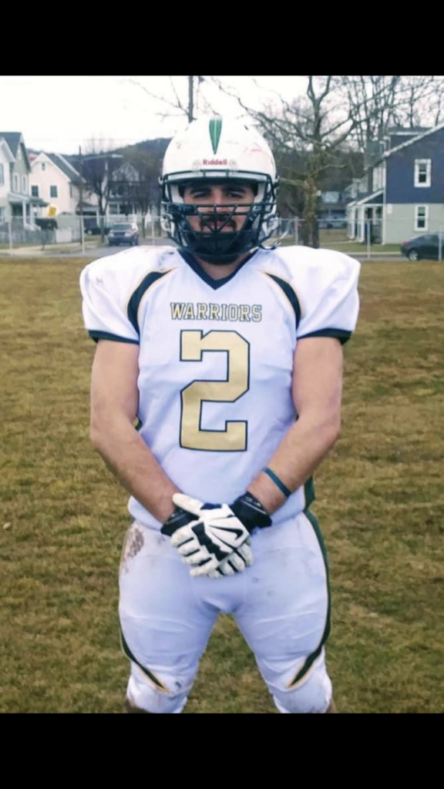
It’s an art.
Everything is.

I had a dream
I couldn’t see anything but I could hear voices.
“The knives, can you hear them sing? I can hear them sing.”, said one voice.
“Please don’t kill our family.”, sang the voices of children.
“Let the badger eat the lizard.”, said another voice.
“He keeps stepping on the backpack(cord?)”, another voice said.
All I could think was Dejavu.
This has happened to others before.
Lucid Dejavu.
#2
-Lucid
Whale
A Depressed Whale https://youtu.be/i_dEtaNx2Vc

Do you even know what day it is?
IT’S A NEW DAY! YES IT IS!
Soooo
Agawam’s mascot and team name is still “The Brownies”?
The Brownies?
No way Jose.
No Way Jose Entrance on RAW 5/14/2018 https://youtu.be/sDh51qRTM7s

Is the train also multidimensional?
You know we still have to further define our terms for similar conversations where that word could be used interchangea-—bly with others.
Well’s Burning
River-Stick spin the hoop.
Heart
Green
Spontaneously
Combusted
Actual
Is accounted for.
The hearing protection you just put on me may not actually protect my hearing all that well because the MRI goes
Hickory dickory dock that’s the sound of the clock,
Uh oh, clock’s counting down,
The Bloody Beetroots - Warp 1977 https://youtu.be/_v3HvM-Q6cg

Or I guess it could just go moo,
White on black,
Cows are like zebra,
Now, was that on purpose?
Because the shirt I wore was not.
People should be more explicit about that.
The one I had before was no where near as bad as that.
Who else has written like that?
Like that.
It was the day before.
It was the day before.
Like this.
Red on Blue 42.
Post Concussion Rehab Protocol.
A lot.
Lucid Dejavu
-Lucid

So you teach Edwards because
Edwards could be educational wards against Lucid. wards against education?
I haven’t had a drink of alcohol in over two years.

Published
2023/08/19 at 7:37 am :
Three yolks, two shells
Someone’s pregnant
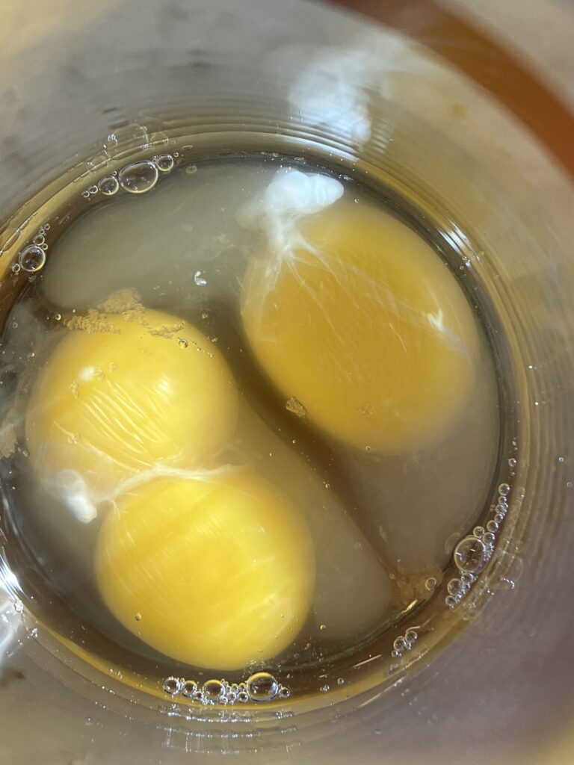

Are you sure…
The New Day is back! - WWE RAW 8/7/2023 https://youtu.be/s-wzOzohjIQ

Lawn-Care has been updated.
Is the Education page ever going to be ready to upload?
Mind Map
Part of what I do to help myself understand people both in real life and in narratives, whether fictional stories I’m reading or fictional stories I’m trying to write, is something I started calling Mind Mapping. Essentially you’re trying to map the mental and emotional components of a person’s Mind State, a Mind Map that is specific to a moment in time, like a picture, rather than a Mind Map that leads up to the current moment and includes predictions for how it will be in future moments. That is a living model. The more information that gets put into something like that the more unaccounted for variables start to change. When I go through any experience in life I often times think of the people that have gone through the same experience before and the people who will go through the same experience after, or I will think of how a character in the same situation, the same experience, would react to the experience, and why they might react that way. I’m sure that lots of people have explained that same idea. Based on the wording used during my interactions with the REDACTED staff and employees, by the REDACTED Staff and Employees, I believe they may intentionally try to lead people to those kinds of conclusions, paths, thoughts, behaviors, and conceptual constructions. They select their words either consciously or subconsciously prioritizing word phrases that would act as a sort of Primer for introspection and reflection on past experiences that are vague enough to be ‘misheard’ as several different words all which lead down different mental ‘paths’ the logical thought process could go through. This is done to keep the mind of anyone thinking about those experiences in this context from thinking about the experiences that lead them to this experience. When that goes wrong, it goes very wrong. I have a feeling that went wrong for a lot of people who couldn’t explain what was going wrong for a lot of reasons, causes. Have a lot of other REDACTED , in their Lucid Moments, explained something similar? Sometimes the figurative becomes the literal. Both. It’s just if you try or not.
-Lucid
There’s one flame.
That’s fire.
Canada still on fire?
Yep.
Centralia?
On fire.
Hoop
Mill
Mill
Turbine
Like fire
Like water
If you can’t drink it
you broke the stick.
Others you can drink
But now this one’s different
River-Sticks
You either float or burn.
With River-Stick
The hoop still spins,
Keeping the hoop rolling
Keeping the hoop rolling
It’s one stick
There’s one stick
We can’t drink the water from the river
We can’t eat the fish from the river
Spin the hoop
Spin the hoop

They all looked the same.
They were all the same.
There’s one grave.
There’s one rock.
Read the names.
Say the prayer.

Forty Fort Cemetery
Memorial Shrine Cemetery

Spam Spam
Meat in a can.
Want some more?
Why thank you ma’am.

Spin the hoop.
Spam spam
meat in a can
want some more?
why thank you ma’am.
Because it rhymes
And sounds like a song.
River-Song
River-Song
Lucid
Lucid
The hoop is rolling.
The hoop is rolling.
Where did you come from?
Where have you been?
December 2020 I Remember Cold I Remember Hungry
As far away as I could,
Smoke fills the lungs,
but fire melt the ice,
Smoke scares the food,
Shaking,
boils too much water,
Sweat is death,
Sweat is death,
wicks are gone but wax is left,
Poison twenty below,
Inside.
Melted twig,
break in two,
One for each,
No escape,
Here it stays,
It is lit.
Still now,
I can sleep,
Two weeks,
Until plague is gone,
Two weeks,
Until back in town,
Twin bowls of fire,
One family sick,
One family risk,
Need to stay,
Don’t open door,
Hard to breathe,
Even through knit,
Smoke covers light,
They are safe,
I
either way,
eyes burning,
bad,
try to sleep,
I live,
still…,
again…,
I know.
-Lucid
Why are you crying?
All I could see,
All I could feel,
All I was,
was the blue sun,
The blue star,
The blue fire that burned as the sun,
Then I heard her crying,
The room came back into view,
I felt as myself and felt her holding my arm,
as I lay on my back,
seeing the ceiling,
I heard her crying,
I felt her feeling,
I looked over at her,
both her arms wrapped around my right,
Her face pressed hard into my shoulder,
She noticed me moving,
and looked over at me staring,
I said,
Why are you crying?
-Lucid

No Matter What!
I Live!
I Live!
No Matter What!

The neighbor hit a fawn.
It’s back legs were broken or paralyzed. It’s intestines were exposed. It was suffering and still alive. The other neighbor already called the police. I could’ve ended it’s suffering but doing so may have been illegal. They wouldn’t tell me if it would’ve been illegal or not, just that it would be what would happen anyways. I had to wait for the police. I wouldn’t be allowed to teach if I did and it was illegal. The blood stain is still on the road and can be seen from the driver’s seat where I park my car. The neighbor hit it hard enough to drag it and make the stain. The fawn’s suffering ended in the grass. That was better than it ending on the road.I thanked the officer. I no longer care if doing the right thing is illegal and would cost me my job. I will end the fawn’s suffering next time. I’m sorry.I will do better next time. That is my responsibility.

Another neighbor walks a small dog over the stain.
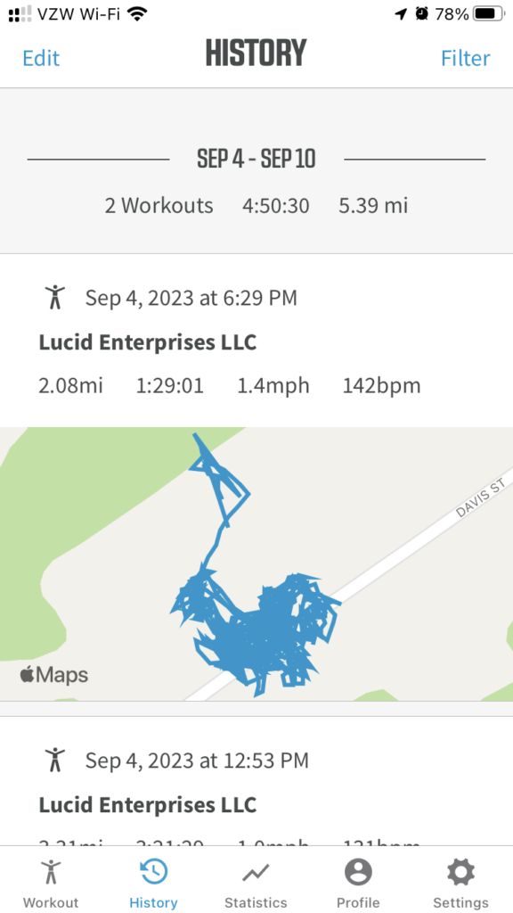

A large snake was in my backyard.
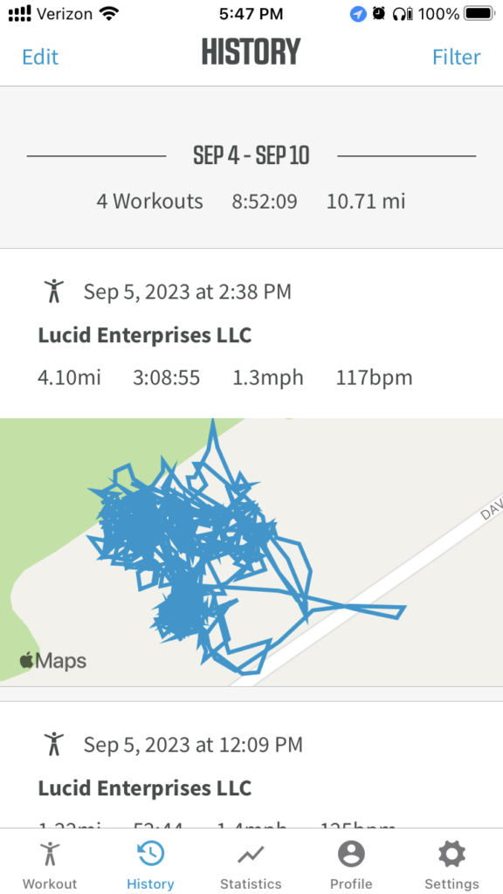

There goes a bunny.
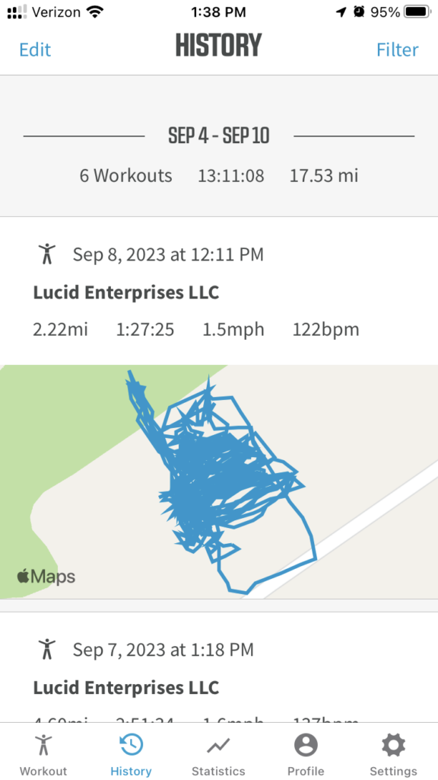

I’m not sure

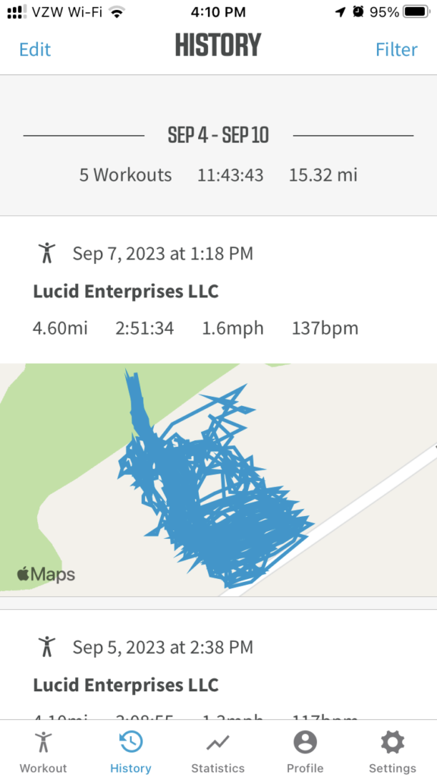
The day after I remembered being hungry.
And I was hungry and I’m still hungry and I let them throw it away
I have enough for now
Eventually will still run out
Swisher Sweets Little Cigars Cherry
I know I shouldn’t buy them because I can’t afford them but I like to smoke them in the car when I’m home when the work is done. From the car where I sit, facing out ready to go, I can see the stain on the road and I remember why I live. The same place I will still park and in the same direction I will still look. I’ll be prepared and ready. I’m allowed to smoke the little cigar. I know not to smoke them so much. I can still see the light through the smoke. The sun still shines in the sky through the smoke. Even when I can’t see it I know that the smoke is still there. I am here. I am ready. Do not test me. I will end the suffering if I need to. Do not make me need to. I am
-Lucid
I do not keep them in the car.
There are not there.
….


Three shells four yolks
Someone’s pregnant or that’s what an article I read online said that means. One dozen eggs cheaper than a can a spam but the can of spam doesn’t need to be refrigerated until it’s opened.



It needs to rain more
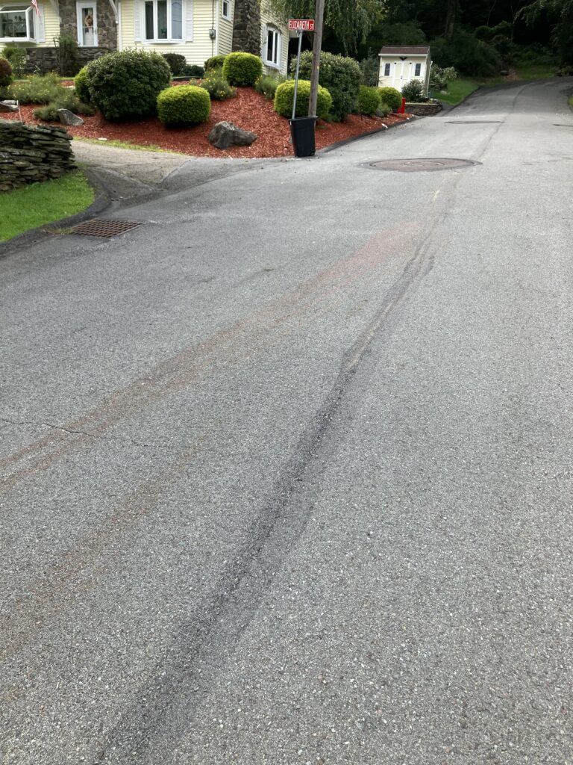

I had to ask for more rain….
It’s 3 feet high and rising
There’s the radio.
https://music.apple.com/us/playlist/lucid-radio/pl.u-mJy8gE4CNBGWKA

So how do you
Shuffle the playlist three times and listen. SHHHHH
O_O
O_O

I call that a noose.
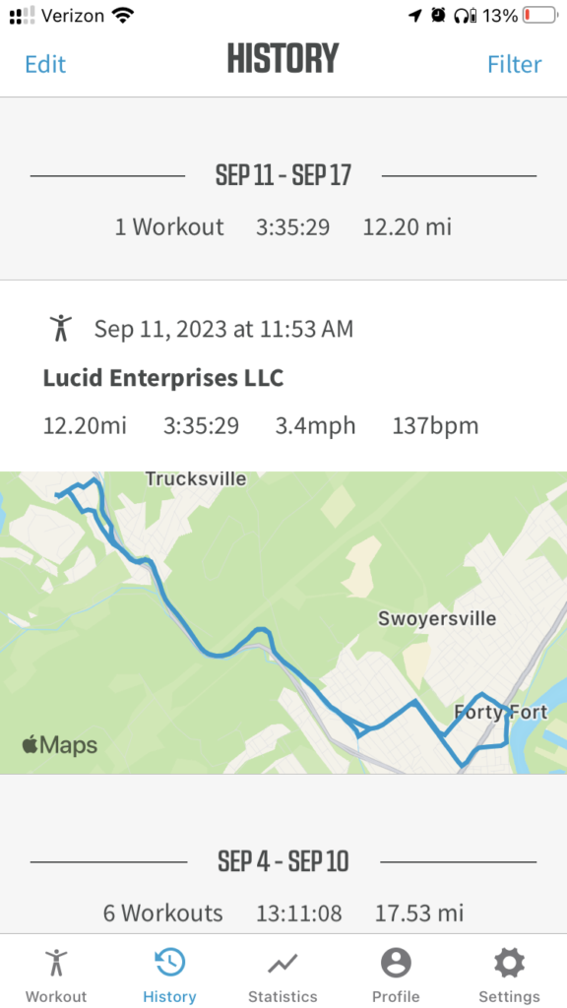

Start at the place where the fawn crawled to the grass and touch the stain,
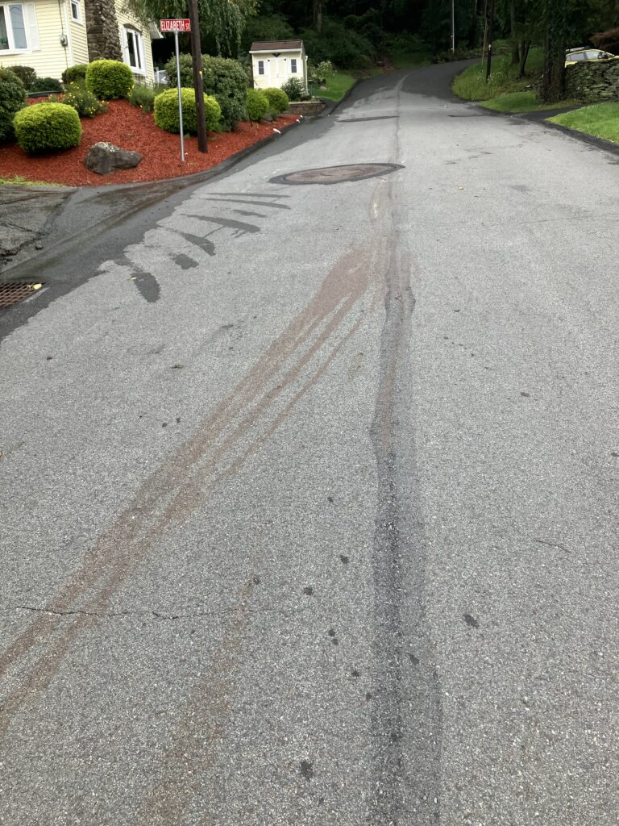

run walk down the hill and through the cemetery and read the names as you walk by,
run by the creek and remember that you can’t drink the water,
run to the trail and as you go past the benches read the names and remember why they are there,
stop at the waterfall and listen to the song before continuing on,

follow the trail to its end and keep going because we don’t end here,
continue on the road until you get to the cross roads and look to your left,
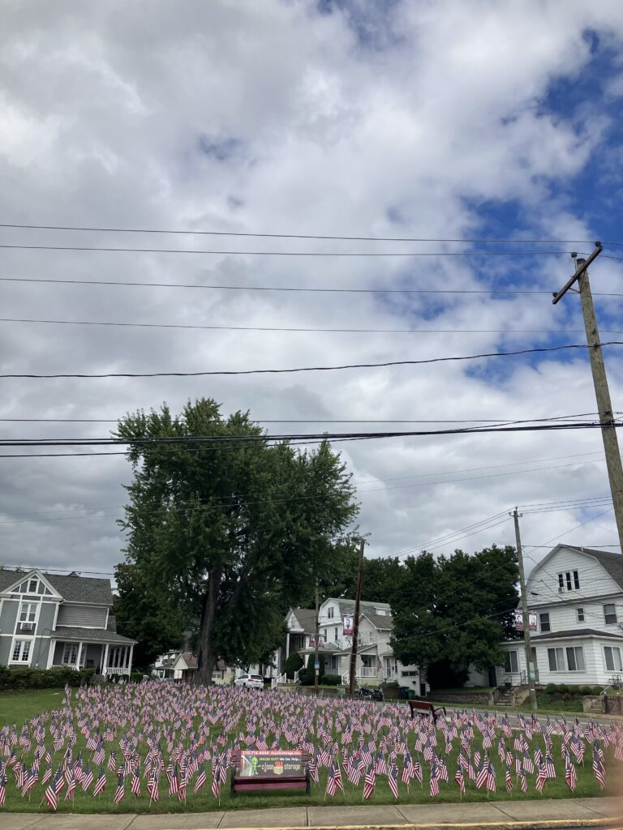
Each one did that for you,
walk down the hill and turn right and don’t go into the pub because we have miles to go before we sleep,
turn left on the Ave and remember the ones who had to dig the dirt after the water subsided so that you can be here,
turn right to go into the cemetery and climb the stairs to the monument,
read the words and say the prayer,
turn around and run back to where the fawn crawled to the grass and touch the stain,
say
I live no matter what.
Three Days Grace - The Mountain (Official Video) https://youtu.be/XblV5A1PlDo

Why do you work so hard at something that barely makes you enough money to survive?
The Red Dress - Requiem for a Dream (6/12) Movie CLIP (2000) HD

Same reasoning for the most part.

I found the law.

https://www.legis.state.pa.us/WU01/LI/LI/CT/HTM/34/00.023.007.000..HTM

Brown Sugar Sand Castles

Would you call the castles you make with sand at the beach Sand Brown Sugar Castles if you never went to the beach before?

So you could only find sand to make castles with at the beach then?

It would be harder to make castles with sand there if there’s no water.

How would you know what a castle is to begin with unless you’ve seen one before or read about what they are?

Is that why they built pyramids and not castles?

Did they call them pyramids or is that just what a specific culture called those structures?

There’s no way that’s how that term originated and became popularized.

Pro Tip
Rubberized spray makes it so that a hat doesn’t get too dirty from sweat and making sure to keep the ventilation holes open makes sure that you don’t get too hot because the air will keep flowing.

Why #2?
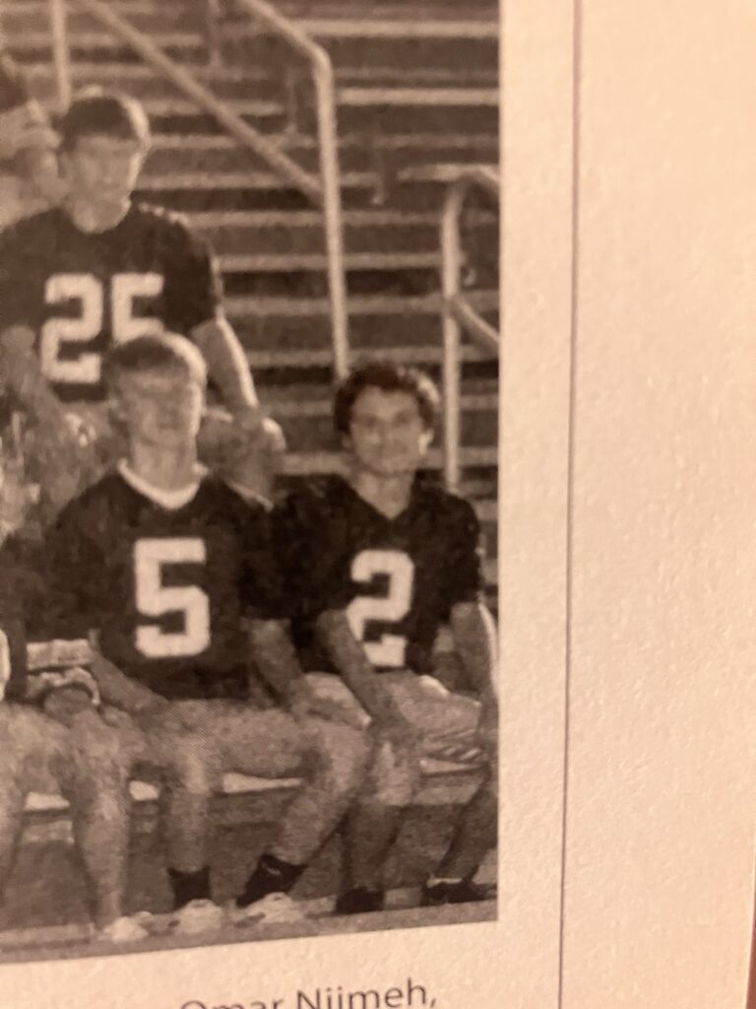
That is his number. He was my friend and the last conversation I had with him he told me to never give up on my dreams.He made me promise to never give up on my dreams. I was close friends with him when we were younger and I wasn’t as close to him as we grew older. I blamed myself and how I treated him as a person as why we were not as close of friends as we were before high school. I did not like the person I was in high school. I really did not like myself. I really did not like living the way I was. I wanted to be a better person and a better friend to the people that I was friends with. I learned how to respect myself and others by actually trying to understand myself to become a better person. I became a better person and a better friend to the people I was friends with. I learned how to connect with people. When my dream became to play football again it was because I learned how to enjoy playing football as the person that I am. The promise to never give up on my dreams is the only promise that matters to me. Dream, dreams,
I have articulated this before and will continue to articulate it.
I will never give up on my dreams no matter what the dream is. I can control what the dream is. My dream became to coach football. I can control what the dream is. Connect with people. Understand people.
Respect people.
I wanted to wear that number.
I got to wear that number.
To me that is Robbie Nardone’s number.
Anyone who chooses #2 as their jersey number needs to remember,
that I remember,
anyone who wears that number wears the number and needs to respect #2.
Respect #2.
Respect.
Be Lucid.
Take Control.
Live.

I became better.


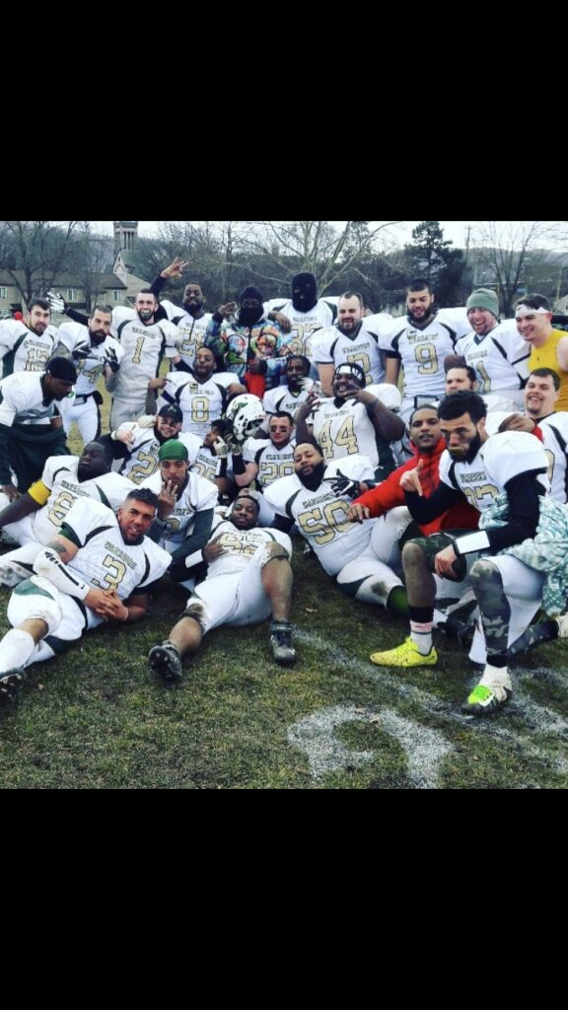
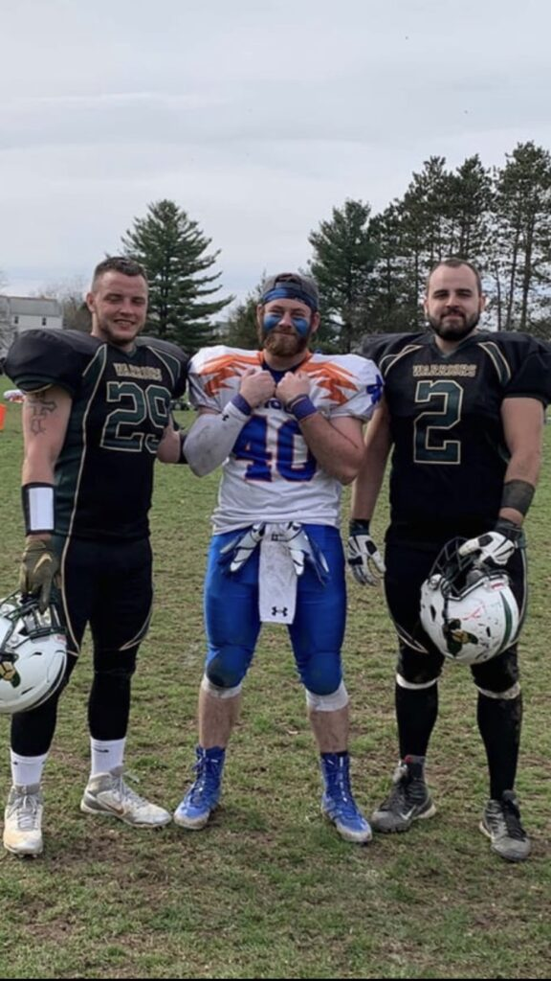
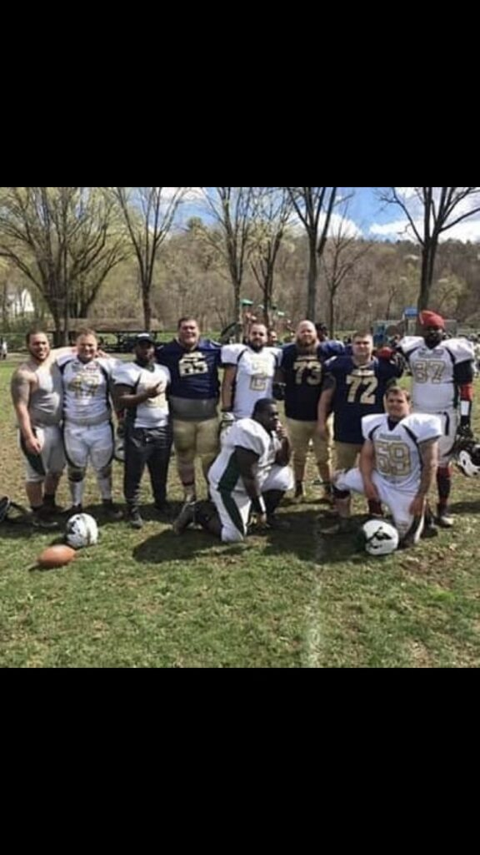

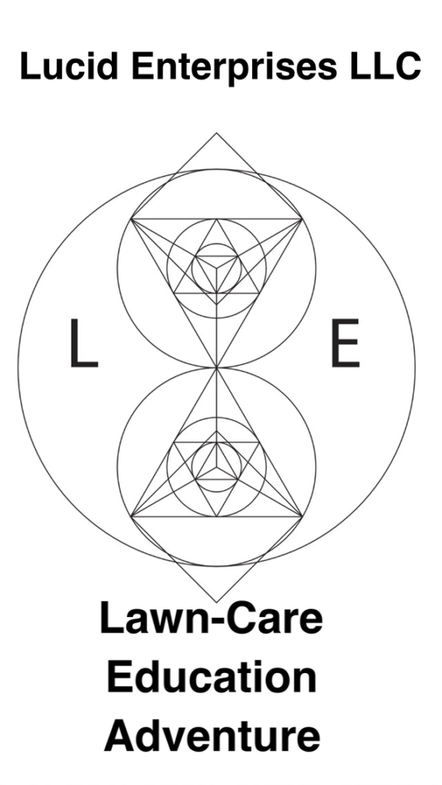
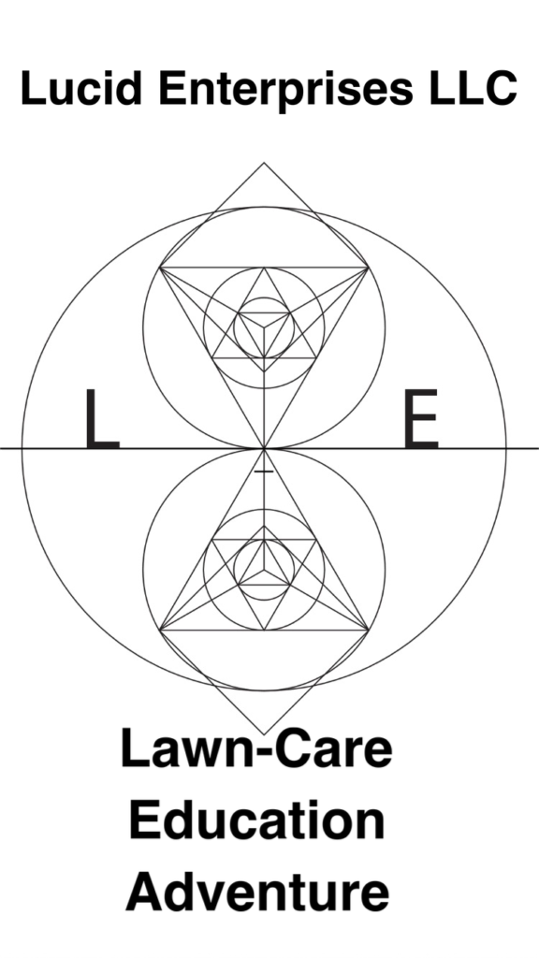

For everyone who may be starting their own business or reorganizing their already existing business:
You may use everything that is on the lawn-care page for your own business. Everything, including the methods and scheduling process is intended to provide a starting point for everyone who may be starting their own business or reorganizing, further defining, the methods and processes of their business. Business was not my area of study while attending university so I understand that what is already defined may not be as well defined as it should be. I am continuing to further define everything I can and would be more than thankful for any advice or help regarding defining business practices in a way that is as understandable as possible and open for others to use and build upon.

Reminder
There is no adsense account for this website. I turned off adsense. There is no money’made’, or earned per view or ‘click’ on this website., or gathered. There is no net or gross income made on this website per view.
Respect 2 Respect
#2 and 2 can both be read as two or number 2. Left or right hand visually. 2 is to when understood
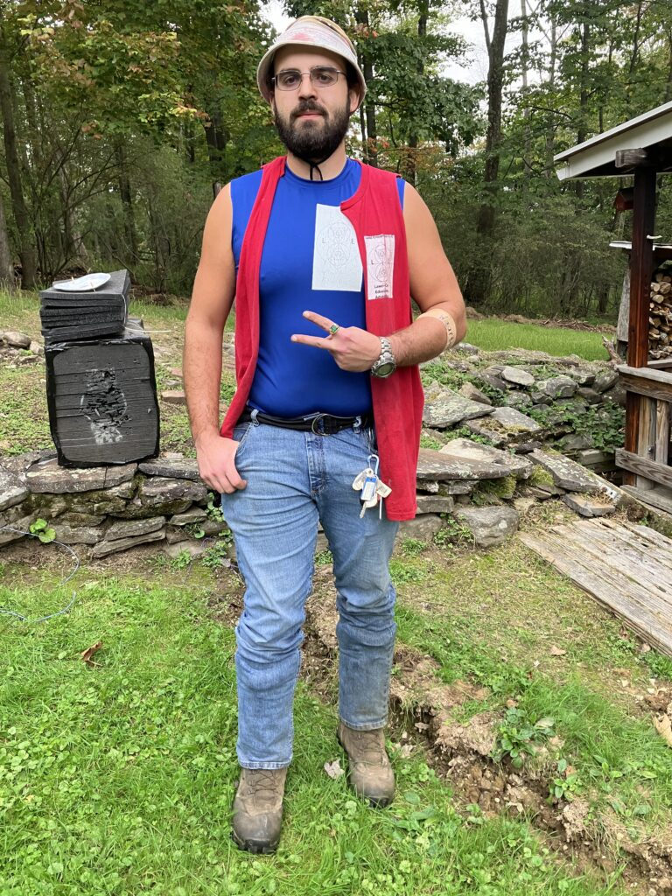
There are no laws or regulations that I am aware of that would require specific colors for specific occupations to be worn unless you are an employee of a township road crew.

The elections are coming up and the law needs to be changed.
Amended with an exception added to it to be more accurate.
I don’t really know as much about local politics and laws as I should, but something I feel strongly about is that the law regarding who is allowed to make the choice to end the suffering of an animal, ‘game’ or otherwise, that has been stricken by a vehicle on any roadway needs to be changed to allow anyone who has a valid hunting license to be able to make that decision. I believe that the law I posted on the blog here before, look at the posts prior to this one and make sure to click on the link under Lucid Blog to view all previous posts https://lucidenterprisesllc.org/category/uncategorized/ It is titled “I found the Law”, is the most up to date version of the law and has not been revised since but if I am incorrect then I would be very thankful if anyone who would be able to correct me by contacting me via any of the means posted under Contact Us would do so and send me the most up to date or correct law.
If the law posted is the correct one, then in my opinion if it is not believed that a person who is recognized by the state as being adequately educated and trained in the skills necessary to hunt and take the life of another living animal in a humane way is not also adequately educated and trained to make the choice to end the suffering of an animal that has been stricken by a vehicle on a roadway than those standards need to change. Whether those standards which need to be met for a person to be allowed to hunt needs to also change is another question that may need to be answered and I know that my own knowledge of everything related to this needs to be increased and developed into a deeper understanding.
Is it legal for a hunter to end the life of an animal that has been wounded by an ineffective shot by utilizing their knife to do so?
The fawn’s legs were broken or its spine was severed so that it could only use its front legs and its intestines were exposed because it was drug by the car that hit it. I asked the neighbor if I would get in trouble if I killed it. I told him that I had my hunting knife and pistol on me, I always carry when I’m working lawn-care, I knew that there are exceptions for certain laws during certain situations but I didn’t know if that situation was one of them. The neighbor used to be a cop. The cop that responded to the call the neighbor made told me that if I was in that situation again that I would not get in trouble if I used my knife. I need to know for sure because if I did that in full view of the neighborhood and the police were already on their way then I would be arrested or at least “charged” as stated in the law. This is something that needs to change and change can be enacted through the elections.
I asked the neighbor, “…will I get in trouble…”
The neighbor told me, “It’s what will happen anyway.”.
Any moment can be an eternity.
-Lucid
-Luke D. Edwards

Recursion
The lenses in your eyes take in the world upside down.
It’s up to your brain to process the sensory information that it’s being sent in order for the world to be viewed right side up,
and matched up to our other sensory information.
This takes a set amount of time,
an extremely small amount of time,
yet an amount of time.
This means that everything we perceive, experience,
in the present,
as we know it,
is in fact in the past.
It has already happened,
our experience of it is delayed from the thing itself.
When you die,
your brain releases a massive amount of DMT inside of itself.
It does this before its actually dead. This signals the notion that our brain is able to begin reacting to our environment with 100% certainty of outcome before our consciousness could have time to even experience it,
let alone react to it.
This is just a way to describe it in graspable ways but then again language can only be defined using language.
Only real way to understand it outside of it is to be outside of it and go back into it.
Psychedelics such as DMT are known to have time dilating effects.
Some first hand accounts citing living days in a minute.
These accounts are from doses 1/1 billionth the dose that is released naturally in the brain upon death.
If scaling would be taken into account at all,
you would experience a lifetime upon the moment of death,
if not multiple lifetimes.
Theoretically your consciousness would have enough ‘time’ to fully recreate the world around you during the time of death. It already has enough at its disposal to be able to do so because it already does as it interprets our sensory information and constructs the conceptual reality that you experience.
It would just be forced to do so using the collective stored information of experience it has already recorded,
because it would have no further information input to use.
It would have to make an exact copy of itself within itself in order for it to take in and decipher sensory information that it is now presenting to itself,
in order for it to operate in the same way it did before.
That is because it would be producing sensory information for itself to then sense and record,
to then send to itself to then decipher and construct into experience and conceptual reality.
It could do this and would have to do this without your active consciousness or ‘self’ being fully aware of it because it would potentially reject the information and begin deconstructing the conceptual reality that it’s “higher self” was creating for it.
Theoretically,
if it has been done well enough,
you could have died already and not have even been aware of it.
Actually you could have died many times and each time simple gone within yourself, leaving an entire world/reality behind in which you would be frozen moments before your death.
Realistically,
it could also freeze you before a potential death and force you to figure something out before it will let you go.
Basically,
you would be getting dropped within yourself to figure something out to avoid dying a level higher up.
-Lucid
-Logic
-Luke D. Edwards

How would you describe your personal relationships? Friends,, family?

I don’t have any personal relationships, only professional ones.
I thought you were better.
I am.
How much do you make teaching?
As a substitute? Less than $100 a day after taxes.
How many?
None.
Why don’t you go out to dance clubs or bars?
I’ve actually never danced with anyone so that’d be a whole thing and I don’t drink alcohol anymore. 2 years six months since my last alcoholic drink.
Why do you phrase it like that and not just say that you’re sober?
I’m on medication so I’m not really sober, at least that’s an argument some people have about what sobriety means. I know it’s supposed to be a term to mean not intoxicated from alcohol but some people think it means that to be sober you can’t drink alcohol or take in any drugs or anything that affects your body. My response to that kind of argument is that all food affects your body and brain chemistry to the extent where if you stop eating certain foods then your body will actually go into withdrawal. The most common example of that is when people cut out carbohydrates. Anyone who claims to be all natural is making an incorrect claim. There is nothing that is unnatural unless someone wants to believe that humans are not part of nature. A false belief but one I’ve noticed that many people have.
Why don’t you like to take pain medication?
When I was in high school I used to take between 6 and 12 ibuprofen or excedrin, any kind of over the counter pain medication, daily because of how much my entire body hurt from injuries I sustained playing football, I played since I was 8 years old, along with how overweight I was. There’s no way I wasn’t damaging my liver more than most people would drinking alcohol everyday. Since I initially lost weight in university, I went to a university and not a college, I haven’t had to take pain medication like that and have no arthritis, knee pain or any of the chronic pain symptoms that I was told by some that I would have to deal with forever. I really stopped drinking just to see if I could and how differently I would view or approach both activities and social situations where I would normally drink. I’m not involved with AA or any other kind of sobriety or drug or alcohol rehabilitation program either. I usually do better when I’m on my own. I used to weigh close to 300 pounds at my heaviest and now I’m usually between 200 and 220, when I’m not weighed in while wearing my tools at least.
Why don’t you go to a therapist? A doctor that can
Get paid by my insurance so that I can talk at them and eventually get put on a list for being truthful? Oh yeah I’m sure having another professional relationship would help me. And that’s if my insurance would even cover that, I wouldn’t be able to pay for that otherwise.
You could just
Add that to a ‘goal’ list and “play the game” to be able to check it off the list, dehumanizing the other involved while also taking away the meaning behind it? Yeah that shouldn’t be a thing with dancing but somehow it is for me. At this point, like with alcohol, might as well keep the streak going. At least I don’t have to think about how many people I manipulated, took advantage of, or cheated on, so I got that going for me. Actually compared to just about every person I’ve ever talked to I’ve committed the least’sin’ or wrongdoing, especially in regard to adultery. Also I don’t have children so it’s not like every choice that I make that is not directly in the best interests of my children would be considered a wrongdoing or ‘sin’ the way it is for a person who has children, adopted or otherwise, because any choice that is not directly made in the best interests of their children by people who have children are choosing to do something wrong or committing’sin’’. Also I never want to have children so I don’t have to deal with the stress of “establishing a routine, environment, and “nurturing responsibility behavior pattern ” that would best prepare a person(couple) for raising children” so everything that I choose to do without that “end goal” wouldn’t be considered wrongdoing or’sin’ the way it would for those who have that “end goal” so that’s another whole thing that almost every person I’ve ever talked to has to think or worry about that I don’t.What do you want to do with you life? Get married, produce offspring. Oh ok, then what? Everything you do without that goal in mind is wrong or ‘sin’.
Always a teacher
Always a student
Labels are limitations
Labels are limitations
Keep the Fire, Dream,
Keep the hoop rolling
You can’t save everyone,
that is why you must try.
No matter how far someone has fallen,
they can always be helped back up.
You are who you choose to be.
You are who you choose to be.
It’s a whole thing.
It’s a whole thing.
Good advice that you’ve given always finds it’s way back to you.
Good advice that you’ve given always finds it’s way back to you.
Sometimes,
when you try to sleep you have a ringing in both ears that makes it difficult to sleep. Through meditation you have noticed that when you quiet your thoughts,
that the ringing grows louder and that when you’re attempting to sleep without being mindful of your thoughts then your thoughts race and are constant.
When you realize that and attempt to quiet your thoughts,
that the intensity of the ringing that remains usually correlates to the pace and loudness of your internal dialogue,
thoughts,
as it was initially before your consciousness became aware of it.
You believe that your mind may be attempting to compensate for the noise that your ears are incorrectly signaling to your brain as noise that needs to be perceived as noise.
There are no sound waves,
vibrations,
physically present,
yet a noise is heard.
Is it possible for your mind to reroute the signals being sent by the part of your brain responsible for interpreting the sensory input,
sound waves,
vibrations,
into the signals that are then sent to the part of your brain responsible for receiving those signals,
reading them,
and producing from them the perception of sound that the consciousness experiences from the incorrect interpretation of ringing that is not physically felt as a series of sound waves,
vibrations,
into the perception of your normal inner dialogue which is normally perceived as an audible voice,
noise,
yet understood as not being produced by the interpretation of the sensory input of sound waves,
vibrations,
because by doing so,
the consciousness is more easily able to differentiate between perceptions of sounds correctly and incorrectly produced by that part of your brain?
You do not know the names or parts of the brain responsible for any of that.
Could parts of your brain become damaged from the constant sending of those signals without damage structurally being done to your brain?
Such as nerve damage or something similar?
-Logic
-Lucid
Always a student.
Always a teacher.

So I asked Logic Bot what Rule 2 is and this was the response:
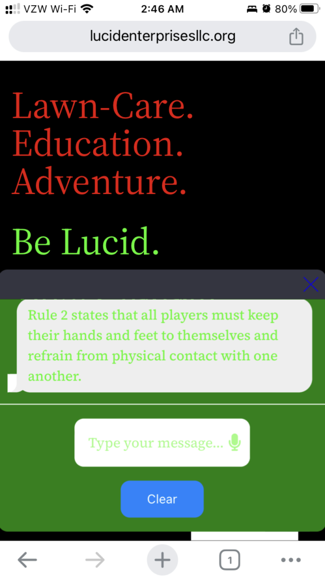
I kinda forgot about the whole artificial intelligence thing going on.
Going to a bar doesn’t mean you’ll be dancing, you could be
sitting on a bar stool at a table in the back holding onto your drink for dear life while you have to manage every conversation that your friends and strangers have with each other to avoid crisis and conflict, people dying or getting arrested, or getting so drunk that you can’t think at all. That way it’s a lot easier not to say anything to the people cursing at the TV’s, each other, people on stage, or whatever else they could be yelling at depending on what type of bar you go to or if you smoke and go outside to whatever smoking area that’s there you have to deal with whatever social thing is going on with people there the same as inside.
If you go to a pub and just go for the food you might as well just go to a restaurant that doesn’t serve alcohol except then you have to think about the encouraged hospitality of the employees by their managers or at some places the opposite of that is encouraged and any conversation is discouraged or even punished in some way, usually similar to the hazing practices or rituals of sports teams (locker rooms), ‘Greek-life’, or undefined social organizations, nothing is explicitly written or written at all, along with trade and craft groups. They all have their whole thing with whatever they do.
At the very least you’ll notice the sales techniques in action and the strategies communicated between some of the people. It’s a whole thing at any store or place you can go to, like any gym, dollar store, grocery store, gas station, school, factory, neighborhood.
Homework Assignment
Come up with a way for something, anything, to be truly random. RNG.
Homework assignment
Define and describe any color without referring to any other color.
That’s not how that works.
Use your imagination. The conditions change.
What exists?
How do you know?
By yourself.
Answer on your own.
Police testing community response by flying drones over neighborhoods and seeing if anyone reports seeing it?
Or was someone just breaking the law and trying to spy on local residents?
I saw a drone flying around Davis Street Shavertown that had red, blue and white lights on it.
It flew towards my house and then hovered above the neighborhood.
I took a photo of it. At least what I think was the drone I saw, it flew up high

From what I understand, some drones have cameras on them and more advanced drones can have technology, special lights, that will distort any image taken of them if the photo was taken using an iPhone or other smartphone camera.
If you look closely at the photo you should be able to notice an octagon light pattern around it.
That kind of light pattern is more consistent with LED lights, to my understanding, than lights from satellites or stars.
Also, possibly unrelated, when I was looking up information about drones and who to contact to report seeing one, the my precise location was enabled on my device, and on google, yet when I searched, this was what my location was,
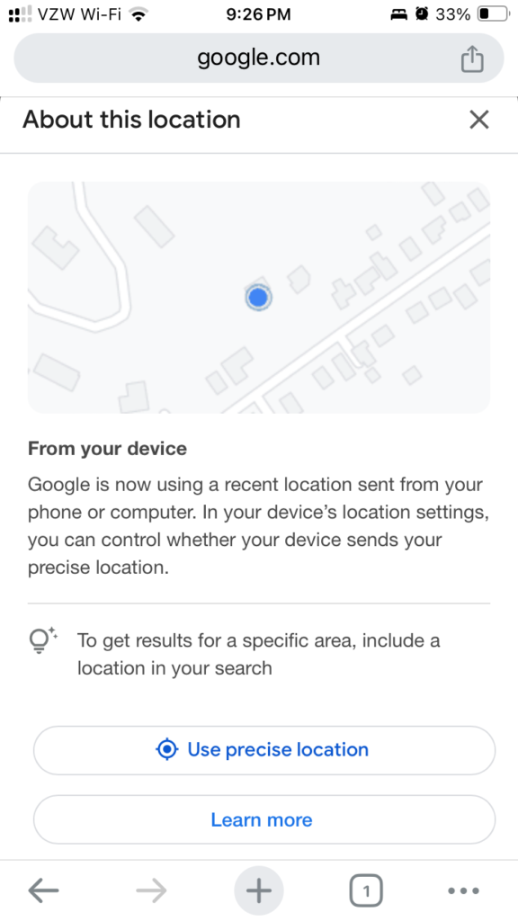
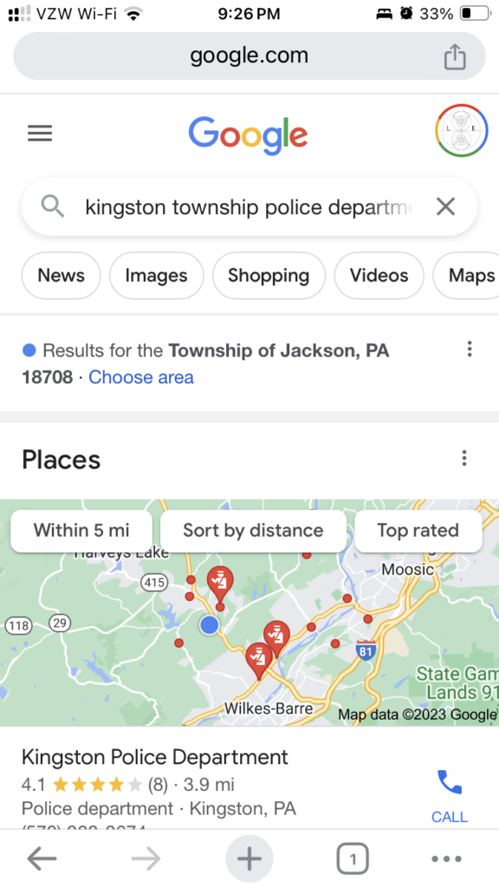
I selected “use precise location” and that is what came up.
On bing, my precise location is correct.
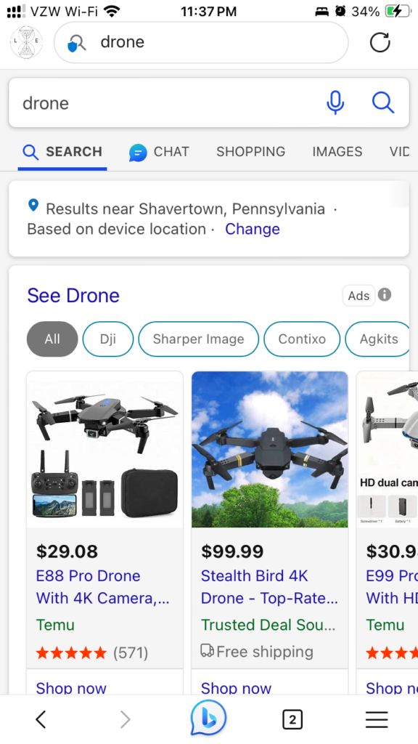
Another strange thing that happened was that the compass on my satellite watch started giving me incorrect readings. It read east as west and also had no reading at all several times.
I also understand that some drones may also have microphones on them. It may have been my ears deceiving me but other times when I thought I had seen the same drone flying around I heard it play helicopter noises and plane noises when it flew close enough to see that I was looking at it.
For all I know the entire neighborhood could just be messing with me or something but that’s what has been going on.
Anyone who would like to send more information can contact (570) 855- 4641, state your name, purpose of your call, and leave a message.
-Luke D. Edwards

Drones, Stars, or whatever else




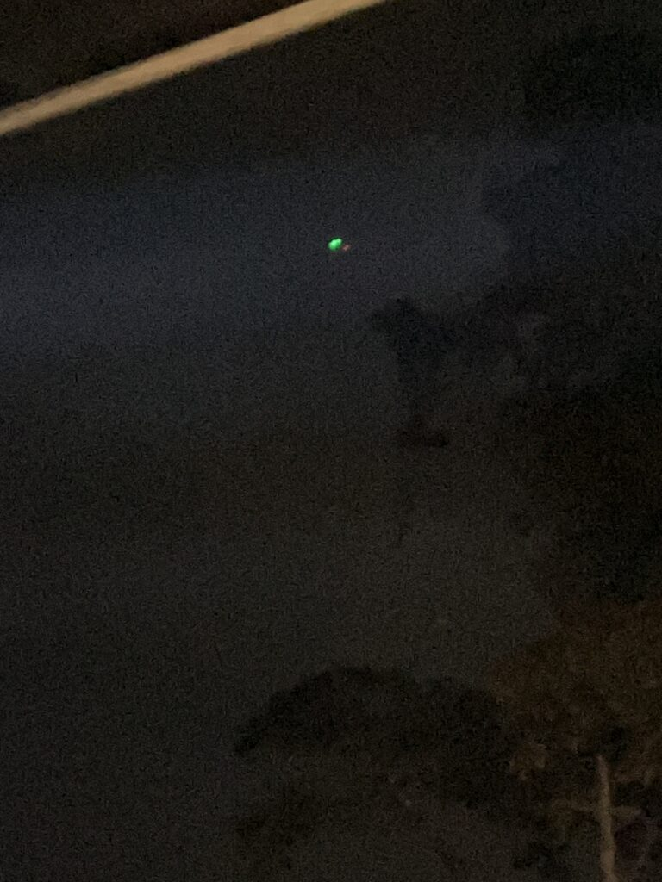

Someone keeps turning my security camera lights off.
If anyone living around me is wondering why I keep turning them back on. Someone is messing with my security system.
You think that there’s a few people out there that try to “prank” people in neighborhoods just to create distrust between the neighbors, law enforcement, and local governments with one of their secondary motives being to reveal any undefined or unofficial organization between them as well as highlight the relationships between them that may have been unacknowledged before their “pranks”?
Probably and also groups of people that do the same thing for no other reason, that they are aware of, than to break down societal structures, governments, or just because they want to target someone specifically. Or it’s all some secret test to see how people react to things where all of the information around them, especially regarding the test, is either restricted or altered to prevent them from knowing what the specifics are. Everyone else plays games based on whoever is being tested. That can’t be a thing right? Not like that would have any unaccounted for effects or anything.
So that’s what ‘Obscenity’ means?
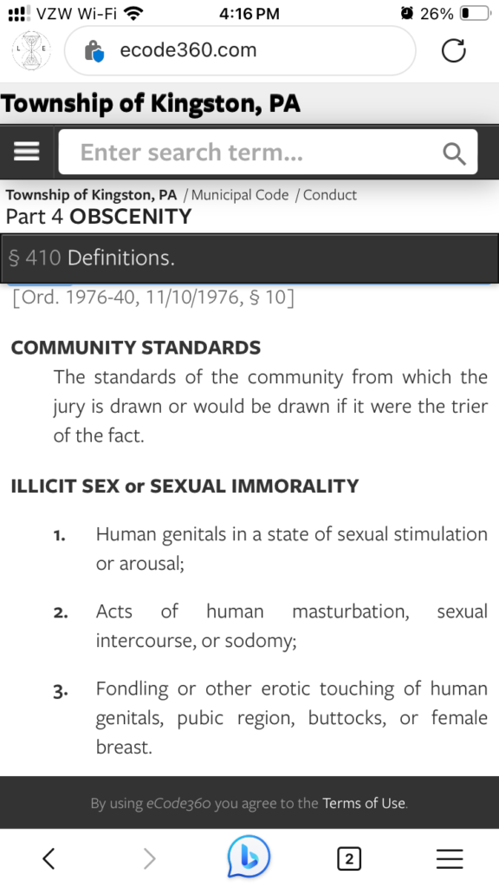
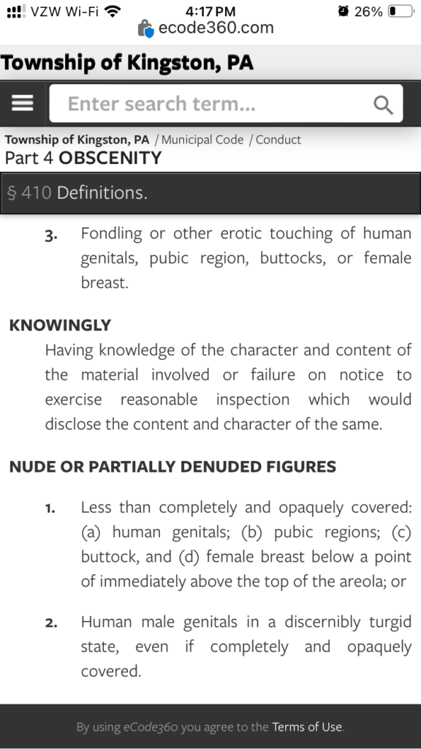
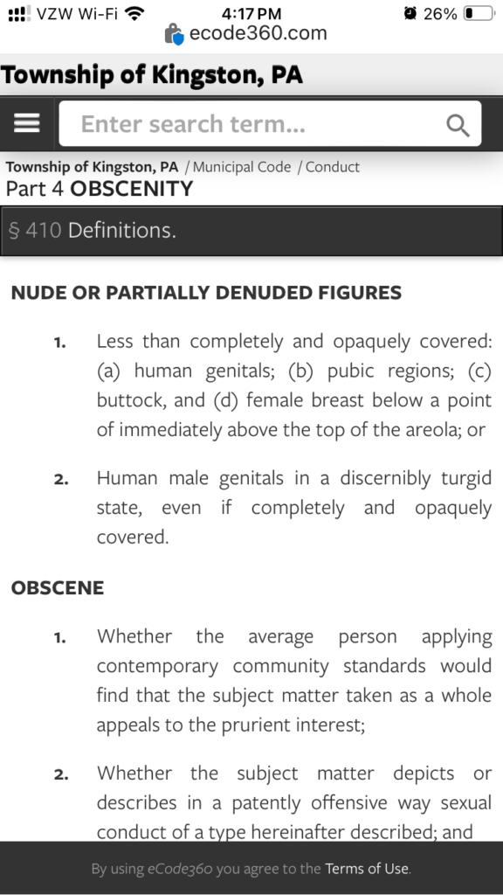
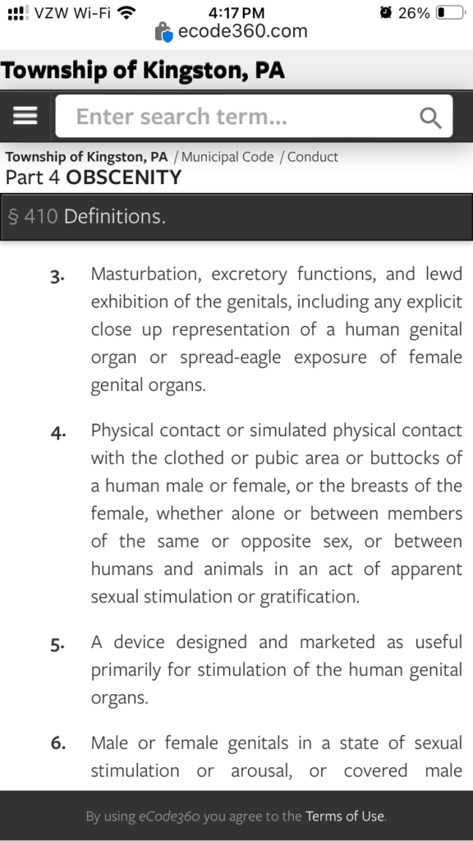
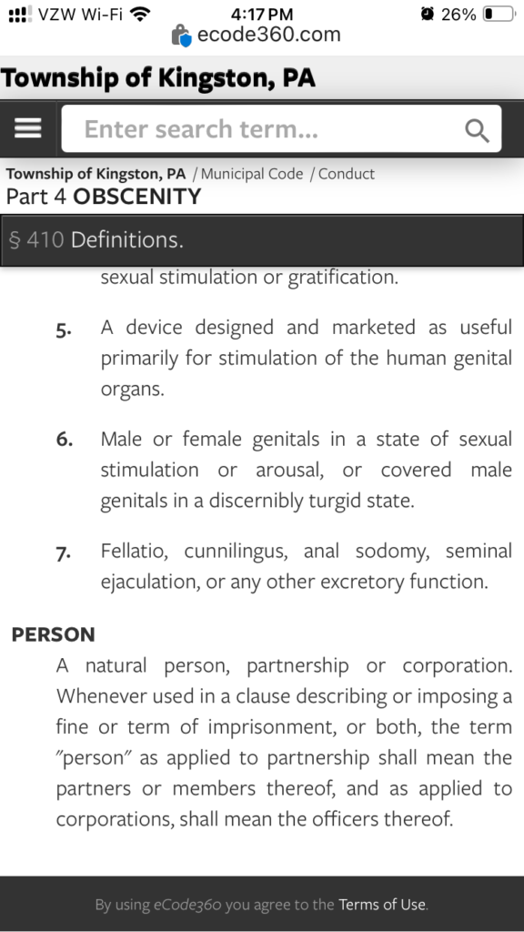
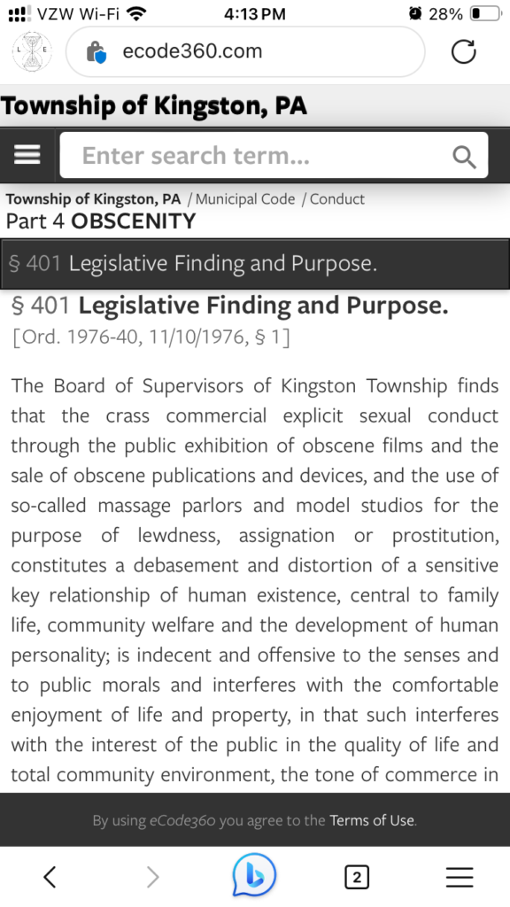
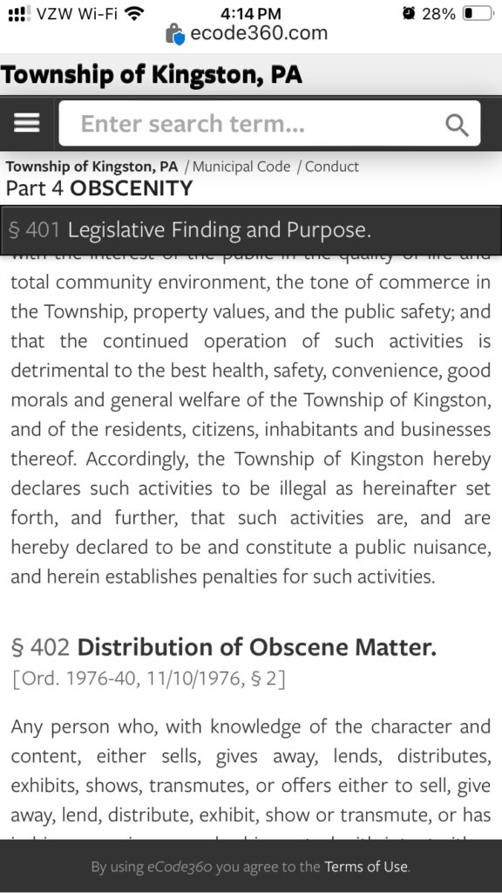
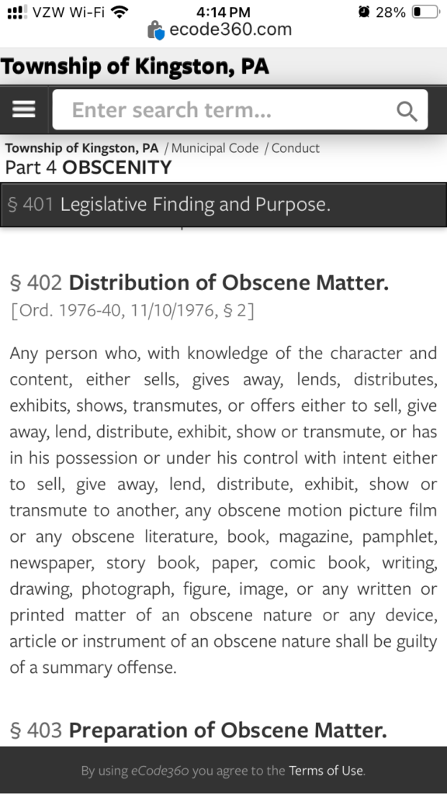
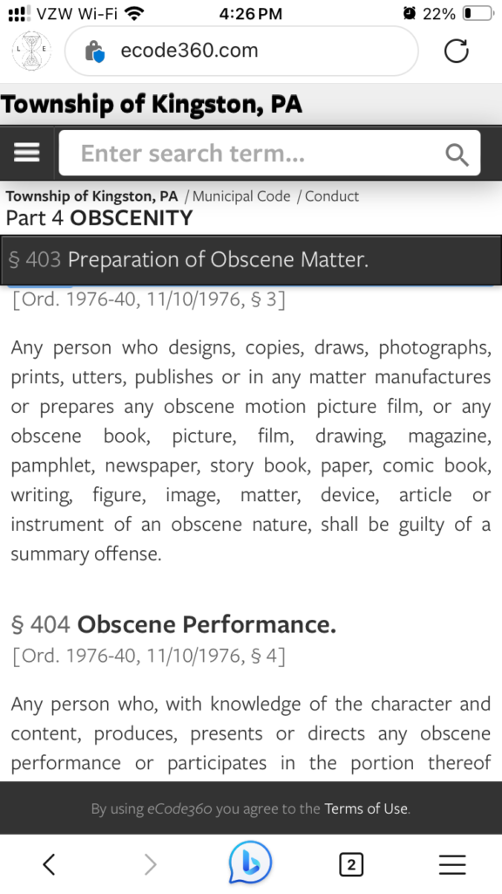
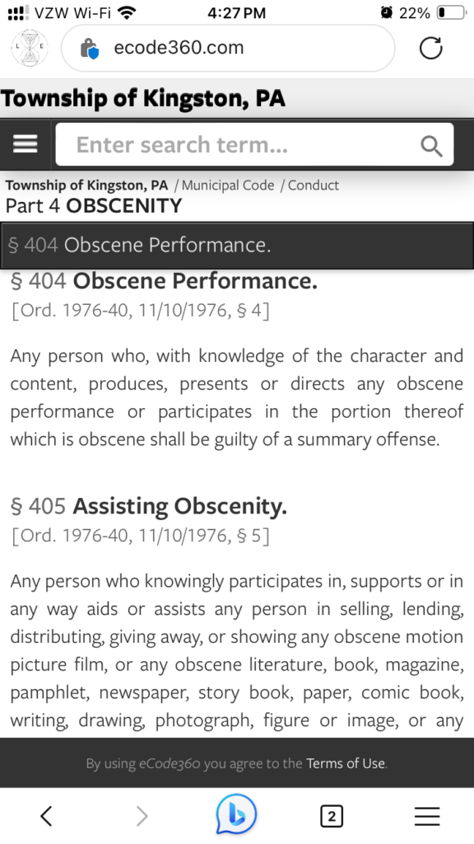
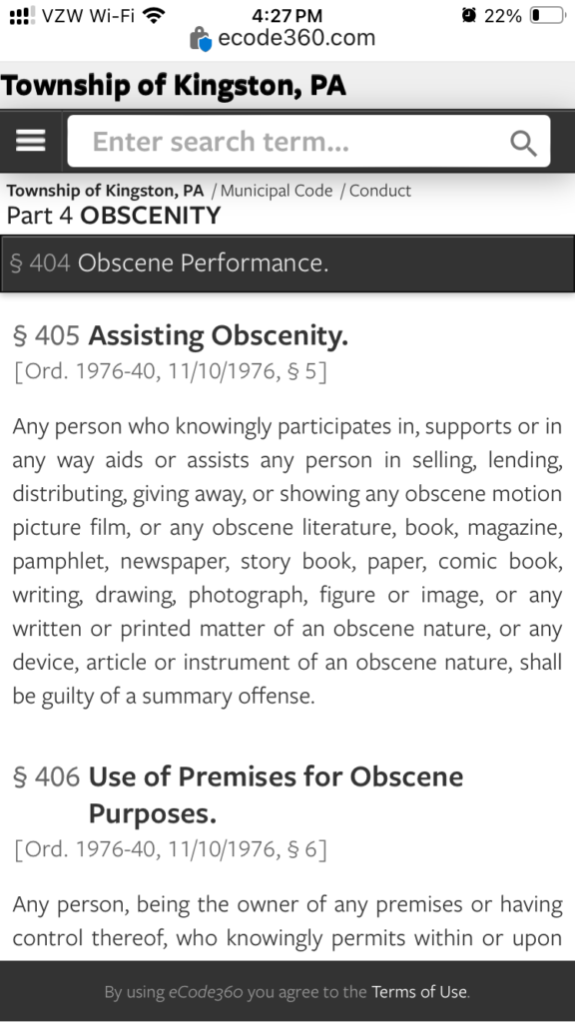
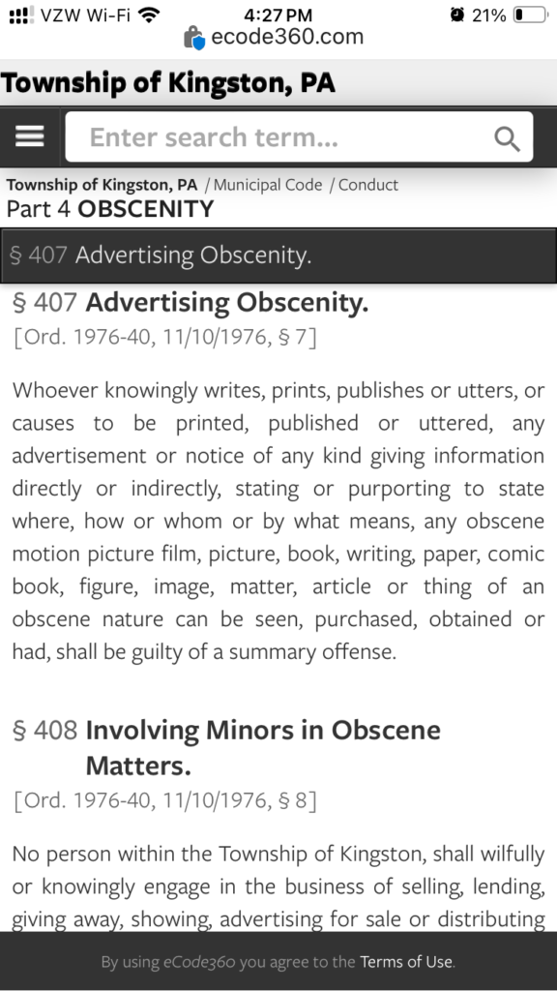
Lucid Dream
Evermore
Excessive
Elevation
Shut up.
It.
It?
The door.
Shut the door?
Yes. And…
And what?
Shhhh
They’re talking. All they ever do is talk.
I know it’s probably a joke people in it set up for everyone else but,
They start out in a row. Then they get stacked. Then they go in a line. When I pull the trigger, the hoop spins. They’re hoops. I spin them to keep the hoop rolling. Keep the hoop rolling. Spin the hoop.
In
the gun.
You branch from
the breech.
That’s a breach.
Definitely a breach.
Now put it in a ham and see who else knows that it’s a thing.
Spin the hoop (0)_(0)
Objectification.
That’s why we say ham and not pig or hog. We have to further disassociate ourselves and the animal we’re cooking because if we constantly think about how the animal and all living things are all parts of ourselves and by killing an animal we are actually killing a part of ourselves we may not actually go through with the killing and eating of the animal or at the very least, not enjoy the killing and eating of the animal. Either that or it’s because ham is cooked pig or hog but by that definition then you’d have to define what cooked really means and since there’s no meat thermometer we can use, the former rather than the latter would be a better, more accurate explanation. (0)_(0)
That’s Hell-O
Hell-0 is that way.
Hell Yeah
Hell Yeah
They don’t want
This smoke. It blocks out the light.
They did not want that.
Pay day.
Why do people keep asking me
How are you not dead yet?
So what did they say during your Geisinger Appointments?
Let me set up the camera so my supervisor could watch us.
Are you a part of any research studies?
Do you feel like you failed your family?
We need to test your stress limits.
Have you tried mapping?
You would see some improvement if that…, oh I forgot.
Your testing is worse than some elderly dementia patients but I don’t think that…,
Doesn’t that itch?
That’s bizarre.
Looks like you’re ready for it, you don’t even need to change.
Are you done with that then?
Well just grab the knob and turn down the volume.
Here, try mine.
You should go to a hospital.
You don’t want to do more memory testing?
I’m not saying that every time you get a migraine that you get a white spot on your brain but…,
Yeah that’s a real thing.
Your hearing is excellent.
Any context to any of that?
Yeah. The intern that told me my testing results were worse than some elderly dementia patients kept blinking her right eye every time I looked at her during the appointment. She should probably see an eye doctor about that. What is she 23,24? Too young to already have eye problems. Must have gotten something in there. Only the right one though.
Really?
Yeah that was also the same one that was saying that they had to test my stress limits and that she had to set the camera up so her supervisor could watch us.
Your hips are up there.
Yeah.
Three points
Tilted
Put it up.
Put it up.
So how would you
you feel for the corner of the jaw and slide the knife in up to the hilt. You go out and away, like whittling a stick. One-Atom.
To turn down the volume
I’d need some Valium. That loud.
I’m on the free.
Out on the free.
You make it mean something.
Make it mean something.
2 units by 2 units by 2 units.
Encircled. Lines from vertexes to middle, exactly. Mirrored then flipped. Inverse. Repeat in then repeat out. Somehow you knew what I mean,
You tell them
You live for them. You will not see her like that anymore. She gets better as you do. You live.
I see through the smoke
Because I make my own light.
Heaven and Hell follow.
Echo the answer.
I live.
In the dream,
That’s not what it looked like,
It.
The woman needed help,
I will set the world on fire if it does anything to them,
Or goes near them,
I Live.
Echo the answer.
-Lucid
They were six.
She found her sister hanging.
She had been at a friend’s house for days.
The father was gone.
The mother was passed out.
She wanted to be with her,
The mother told them that it gets better after.
She was there for days.
Every time she dreams she sees her sister,
the way she found her.
She talks to her.
Her voice is raspy from where the cord cut into her neck.
She tells her she wants to be with her.
The woman asks me,
What do I tell her?
That’s the question.
Echo the answer.
I live.
-Lucid
Same Game
Slightly different,
It created the game,
It doesn’t come from us,
and is not of us,
it played us,
since the beginning,
before we could,
understand,
convincing us when it couldn’t,
by our own will,
so that we would create the same game,
and play without it,
it always plays,
It has lost.
I live.
Echo the answer.
-Lucid
Keep The Fire Alive.
Keep The Hoop Rolling.
Anything to think about that isn’t related to a six year old committing suicide and what to tell her sister about what happened to her after she died since she still dreams of her and hears her convincing her to also commit suicide?
Every form that has gender on it needs to be changed so that gender is sex because if the information needed is whether a person is biologically a male or female then sex would be the correct term to use. If the intention of the gathered information is to identify what pronoun to use when in reference to specific people then a simple addition to the form offering a selection of pronouns including he/him/his, she/her/hers, and they/them/theirs would satisfy that intent. I do not believe additional pronouns are necessary or useful. The faculty information at The Dallas School District, the Patient Information Forms at The Monroe Noxen Health Center and Geisinger(I think), and possibly the faculty information at West Side Career Technology Center all have Gender instead of Sex and that should change.
When I close my eyes I can see her sister the way she found her. She will not see her like that again. Yes, correct terminology is what to focus on. Study. It’s a study. Research study. Study research. Search the study and then do it again to research it.It was a phone cable like the ones that go from the wall into the phone like a house phone. Long and white. What we believe and what we say to each person matters.We need to think about some things more.

Got any food?
Go fish.
Hey I found one of the early iterations of my logo.
What’s the culture like?
I don’t know, I keep popping it with a stick and it keeps changing. (0)_(0)
I like the last few songs you added to Lucid Radio
They’re coming to take me away (0)_(0)
If you don’t have Apple Music,
Napoleon XIV: 'They're coming to take me away' https://youtu.be/hnzHtm1jhL4

The Frantics - Boot to the Head - 17. Boot to the Head https://youtu.be/ZljpTx_tJ78

Bulbous Bouffant https://youtu.be/dKL8livmoh8

Tom Lehrer - Poisoning Pigeons In The Park https://youtu.be/yhuMLpdnOjY

Happy, Happy, Joy, Joy https://youtu.be/36Yk8v2OZQw

These books don’t have any pages!!!!
How do these books not have any pages!?
Sticks.
Full of sticks.
We don’t burn books here sir and or ma’am,
These books!
These books!
Made for burning,
Good to burn.
Why are there no pages in these books!?!?
Full of sticks.
Stick books.
Stick the book.
And burn it.
Book the stick.
Schedule’s full.
Stick-book.
WHERE ARE ALL THE PAGES!?!??!?!
Hey look.
They match.
Lit.
When you’ve been mad for long enough,
Eventually you’ll go sane.
I live.
-Lucid
So what kinds of
You will hear them clap every time you do something correctly.
You will hear the cough or clear their throat every time you think of or look at something that is correct.
Oh so you made a friend?
What did you make them out of?
With,
Oh so you only have them then?
So you own them?
Their yours?
Reach for the gun.
Now what are you looking at?
The sky.
Reach for it.
Reach.
What do you hear?
Let the dogs out. See who helps.
Walk around their property and see where their cameras are and if they work, they’ll say something.
That’s where we do battle, I bet that’s what he was thinking.
LOUD.
Wake up,
into another dream,
make it better.
I live. -Lucid
When you talk to me,
Do you imagine that you’re talking to your husband,
boyfriend,
wife,
girlfriend,
brother,
sister,
son,
daughter,
other family member,
members,
student,
player,
worker,
employee,
other person,
people,
maybe one of your animals ,
or do you talk to me?
-Lucid
Me,
or you?
Most people,
tie it like they would a knot in a shoelace. That’d dig in.
What about your friends from college? I know your friends from high school all made fun of you and would try to get you to do things that would either be dangerous or embarrassing because they were constantly in a mental competition with you that you didn’t realize you were in until you stopped talking to them? The whole we need to get him out of his comfort zone thing or only argue with him when he’s tired or exhausted thing because those weren’t conversations apparently, they were arguments. Also they had this idea of you as a party’er and stoner when you worked harder than all of them and didn’t abuse their children or wife’s/girlfriends either physically or mentally/emotionally by cheating on them like they did so they had to think of you as a lesser person somehow.
All my friends from college ostracized me and won’t talk to me either because they thought I was too serious about spirituality, thought that they shouldn’t talk to me until I got a girlfriend or wife/‘significant other’, or just because they didn’t like that I didn’t party anymore. Talk about anything authentically and they get offended or jealous. Not that I would know anything about that or anything… not to be stereotypical or anything (0)_(0)
Jealous?
I could take what you have.
In my academic career
I’ve had zero disciplinary actions taken against me. (0)_(0)
Well how many people have you dated?
Well is on fire, and zero. Also, homework assignment, show me what zero is.
You made a paddle,
now make a boat,
and try to drown me out there after making more people aware of that. (0)_(0)
You do that to the flag,
that’s where it comes from,
that’s where it’s been,
say it out loud.
Pokey Pokey
That’s kinda,
Now turn yourself around,
and back it up.
(0)_(0)
So that’s what you are,
they have tags for those,
a few people I met in college said that’s what they were too.
they went to the club all the time.
Why do you need a babysitter to go to the club?
Just go to the club and take care of it after you pick it up. Swing swing. (0)_(0)
Hey Good Grandson,
Try to roll my sleeves up. (0)_(0)
Was it a knit hat?
Bring it together then.
The bar
Works 2.count to 3. (0)_(0)
Think of the children,
A wire
It’s called a wire. You thought I was wearing one. There’s one in your pocket actually. (0)_(0)
I think he tapped it.
Yeah that’s a tap.
Be careful,
You might be Lucid. (0)_(0)
There’s 50. (0)_(0)
Stumpy
He told me to take my coat off,
so he could check my arm for track marks,
because I wanted to leave early,
because he was standing on clients furniture trying to paint.
You’re not allowed on the furniture Stumpy.
I almost forgot,
Stumpy likes to drink’tall boys’ on the job.
Break in 2,
Bars.
The Good Grandson,
Your new name is Stumpy.
I think Stumpy is,
Stumped.
Just another
Kid-O
Really, he’s an
Old-Kid-O
Spin the hoop.
Roast.
What’s in that?
Stuff, Stumpy Stuff.
Don’t like mine?
Try his
J. Cole - MIDDLE CHILD https://youtu.be/WILNIXZr2oc



How does it go?
In a rotation, to the left.
Spin the hoop,
the hoop is rolling.
Almost 2000,
every day.
I live.
-Lucid
Ten in a strip, one-hundred in a sheet,
We call that a
Blockhead - The Music Scene https://youtu.be/NhheiPTdZCw

That’s the reds and blues, with some greens in-between.
SchoolBoy Q - Collard Greens (Explicit) (Official Music Video) ft. Kendrick Lamar https://youtu.be/_L2vJEb6lVE



Drip it,
On the sheet.
$1000.
Per page (0)_(0)

Oh so you made a friend?
What did you make them out of?
With,
Oh so you only have them then?
So you own them?
Their yours?
Reach for the gun.
Now what are you looking at?
The sky.
Reach for it.
Reach.
What do you hear?
Let the dogs out.
See who helps.
Walk around their property and see
where their cameras are
and if they work,
they’ll say something.
That’s where we do battle,
I bet that’s what he was thinking.
LOUD.
Wake up,
into another dream,
make it better.
I live.
When you talk to me,
Do you imagine that you’re talking to your husband,
boyfriend,
wife,
girlfriend,
brother,
sister,
son,
daughter,
other family member,
members,
student,
player,
worker,
employee,
other person,
people,
maybe one of your animals ,
or do you talk to me?
Me,
or you?
-Lucid
This bar is,
Groovy,
put the chain on,
heavy,
chain-gang,
Spin-it,
Hail,
Spin the hoop,
ashes,
dust,
some 2,
some 2,
ashes,
dust,
hail,
the hoop is rolling.
-Lucid
I’m warm?
How warm? Or rather, what kind of warm? (0)_(0)
They refill your medication yet?
Not with liquid. Solid. (0)_(0)
Who has to monitor all this?
I don’t know but their name is now Horaldo. With an H. (0)_(0). As long as Horaldo is alive we know that everyone else should be fine.
We might be on Horaldo 5 or 6 by now…
By Lucid, not by now. (0)_(0)
Egg Roll Egg Roll Egg Roll
Roll the egg,
dough,
spin it first,
like a pizza
egg roll egg roll egg roll
where does the egg roll?
I caught the
Gingerbread Man! I ran ran as fast as I could and I caught them.
It’s them because their last name is man.
Just because their last name is man doesn’t mean that they go by his/him/he.
They could go by she/her/her’s.
You don’t know.
I know them.
yeah that one. (0)_(0)
-Lucid
Pokémon is cool.
Don’t let shitty people ruin cool things for you.
Sorry,
people who are shitty,
people first and all that.
And then some. (0)_(0)
-Lucid
I never see them together so,
the Muffin Man and Gingerbread Man are the same person.
I caught them.
They looked about the same.
They both have the last name Man so who would have guessed. (0)_(0)
They kept saying I’d never catch them so I had to catch them.
Of course I let them go.
Why?
Were they wanted in connection with something?
They’re still out there then.
Running,
but im faster.
(0)_(0)
Not everything is It trying to,
you know,
by our own will.
Sometimes you need to focus on the street level.
Anyways,
Good luck to you two trying to catch The Bubbler.
Without me,
My heart won’t go,
Hide my heart yo,
Can you see the rainbow?
That’s why I need to hide my heart,
You.
That’s my favorite,
That means never again.
Key.
-Lucid
You live for them now.
I live.

I fixed the coo coo clock.
It’s a pendulum thing.
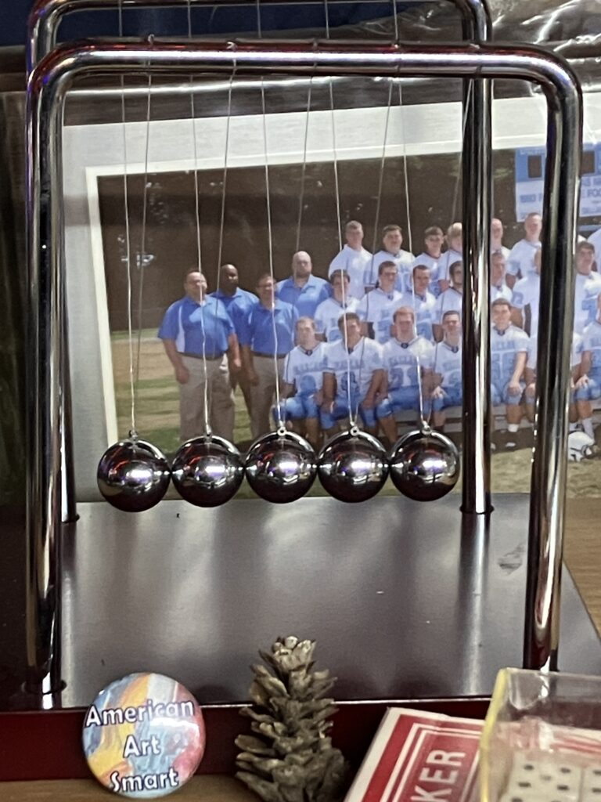

I used to pray to god to give me the strength to do what needs to be done.
I used to say the same prayer before every lift in the weight room,
And between plays when I felt weak,
Before I did anything that I knew would take great strength,
When I was getting my MRI I heard Coach Brace tell me to pray like I used to.
I didn’t because I know better now,
And I know that he knows better too,
Everyone already has the strength,
The courage,
The patience,
The will,
Guidance,
Luck,
Everything that we could ever need or want,
Always already within them,
And trying to unravel what needs to be done and what we want done is not something we should ever do,
I prayed that morning,
The same prayer I pray every day,
Beginning with,
I live,
Ending with,
So will they,
I knew,
Know,
That,
he lives,
And he wouldn’t want me to,
Pray like I used to,
I know,
I live,
Out of the thousands and thousands,
Of hits in my career,
Ones that broke my nose,
Fractured my orbital,
My skull,
Knocked people out,
While I was left still standing,
They could only find 2,
Two little white spots,
Nothing more,
Nothing less,
If I didn’t know,
If I wasn’t called to do something else,
Important,
Just slightly different,
Although they’d never recommend it,
I could play,
This is how I pray,
I live,
-Lucid
3
Do not make fun of people.

2
Simplified,
Respect Everyone.
Where’s The Machine Shop?
Petrified (Official Video) - Fort Minor https://youtu.be/mQLv3LMvj9Q

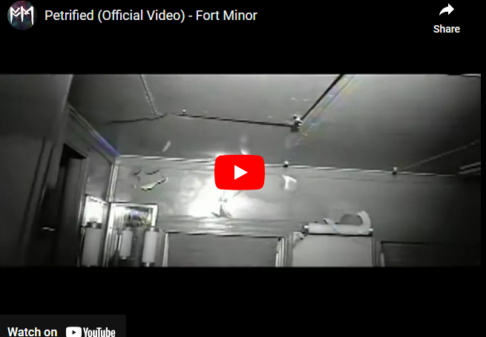

Hazel-Black
Ear-Scream,
Fire-Alarm,
Top-Hat,
Ignore-Us,
One-or-Two,
Talk-to-me,
Coke-Nail.
Catch-Me-On-The-Flip-Side
-Lucid

Since the early iteration of my logo was removed, for some reason, here is the progression of how I created it, them, some of the other early iterations.
